Exercises: JS Back-End and APIs
Exercises and homework assignments for “Full Stack Apps with AI” course at SoftUni.

Install Postman
Create a free profile in the browser version. Click the [Sign Up for Free] button: https://www.postman.com.
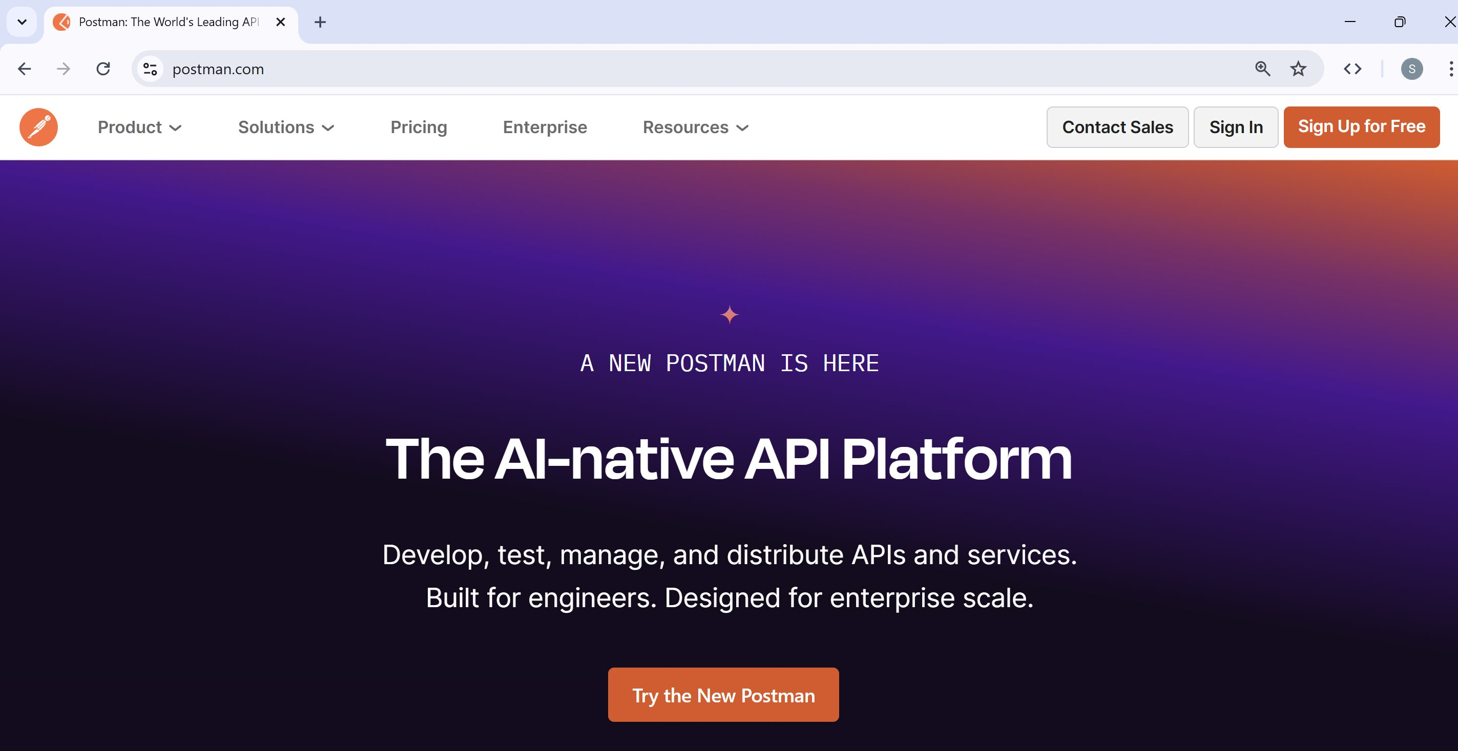
Fill in the required information:
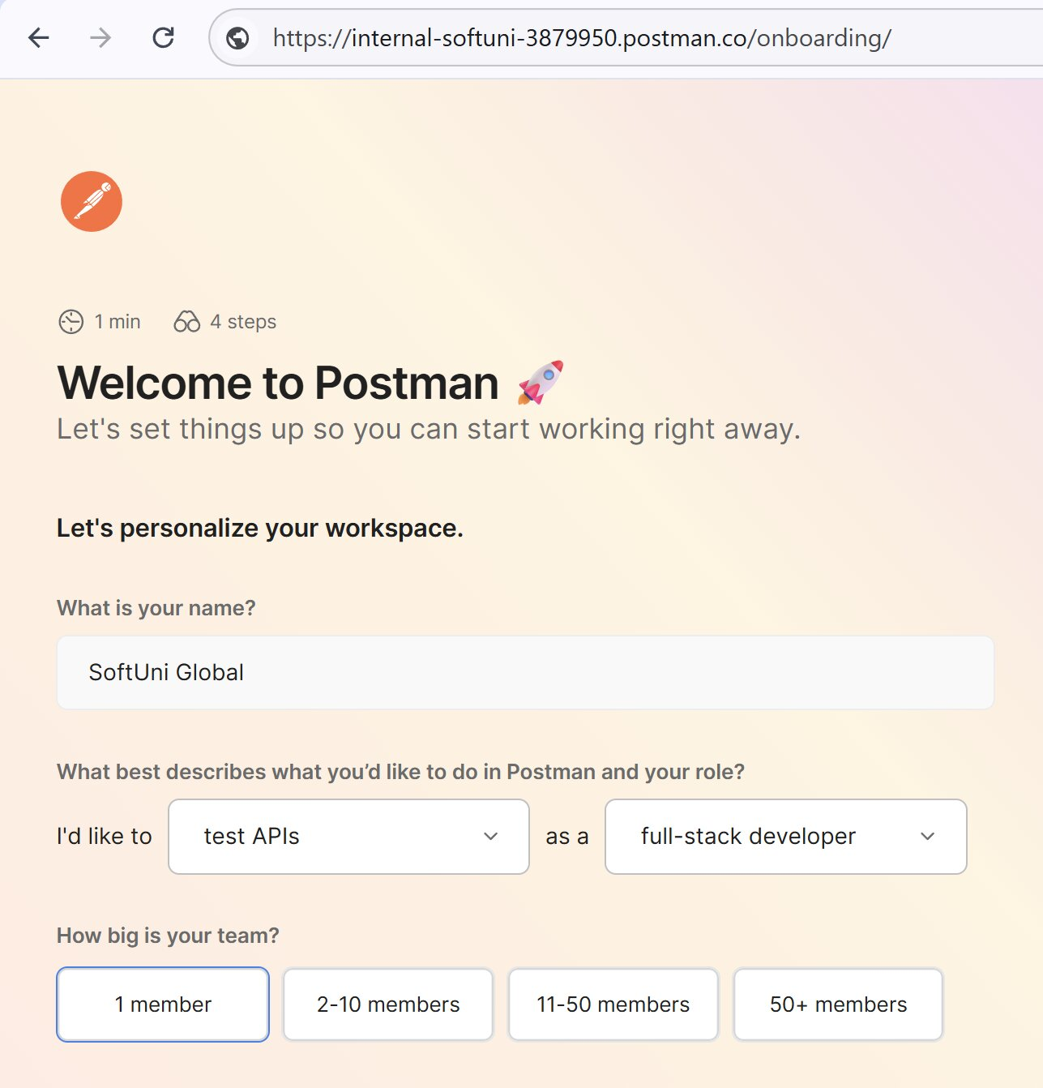
This is how the sample workspace will look in the browser with some sample data and instructions from the built-in AI chatbot to the right:
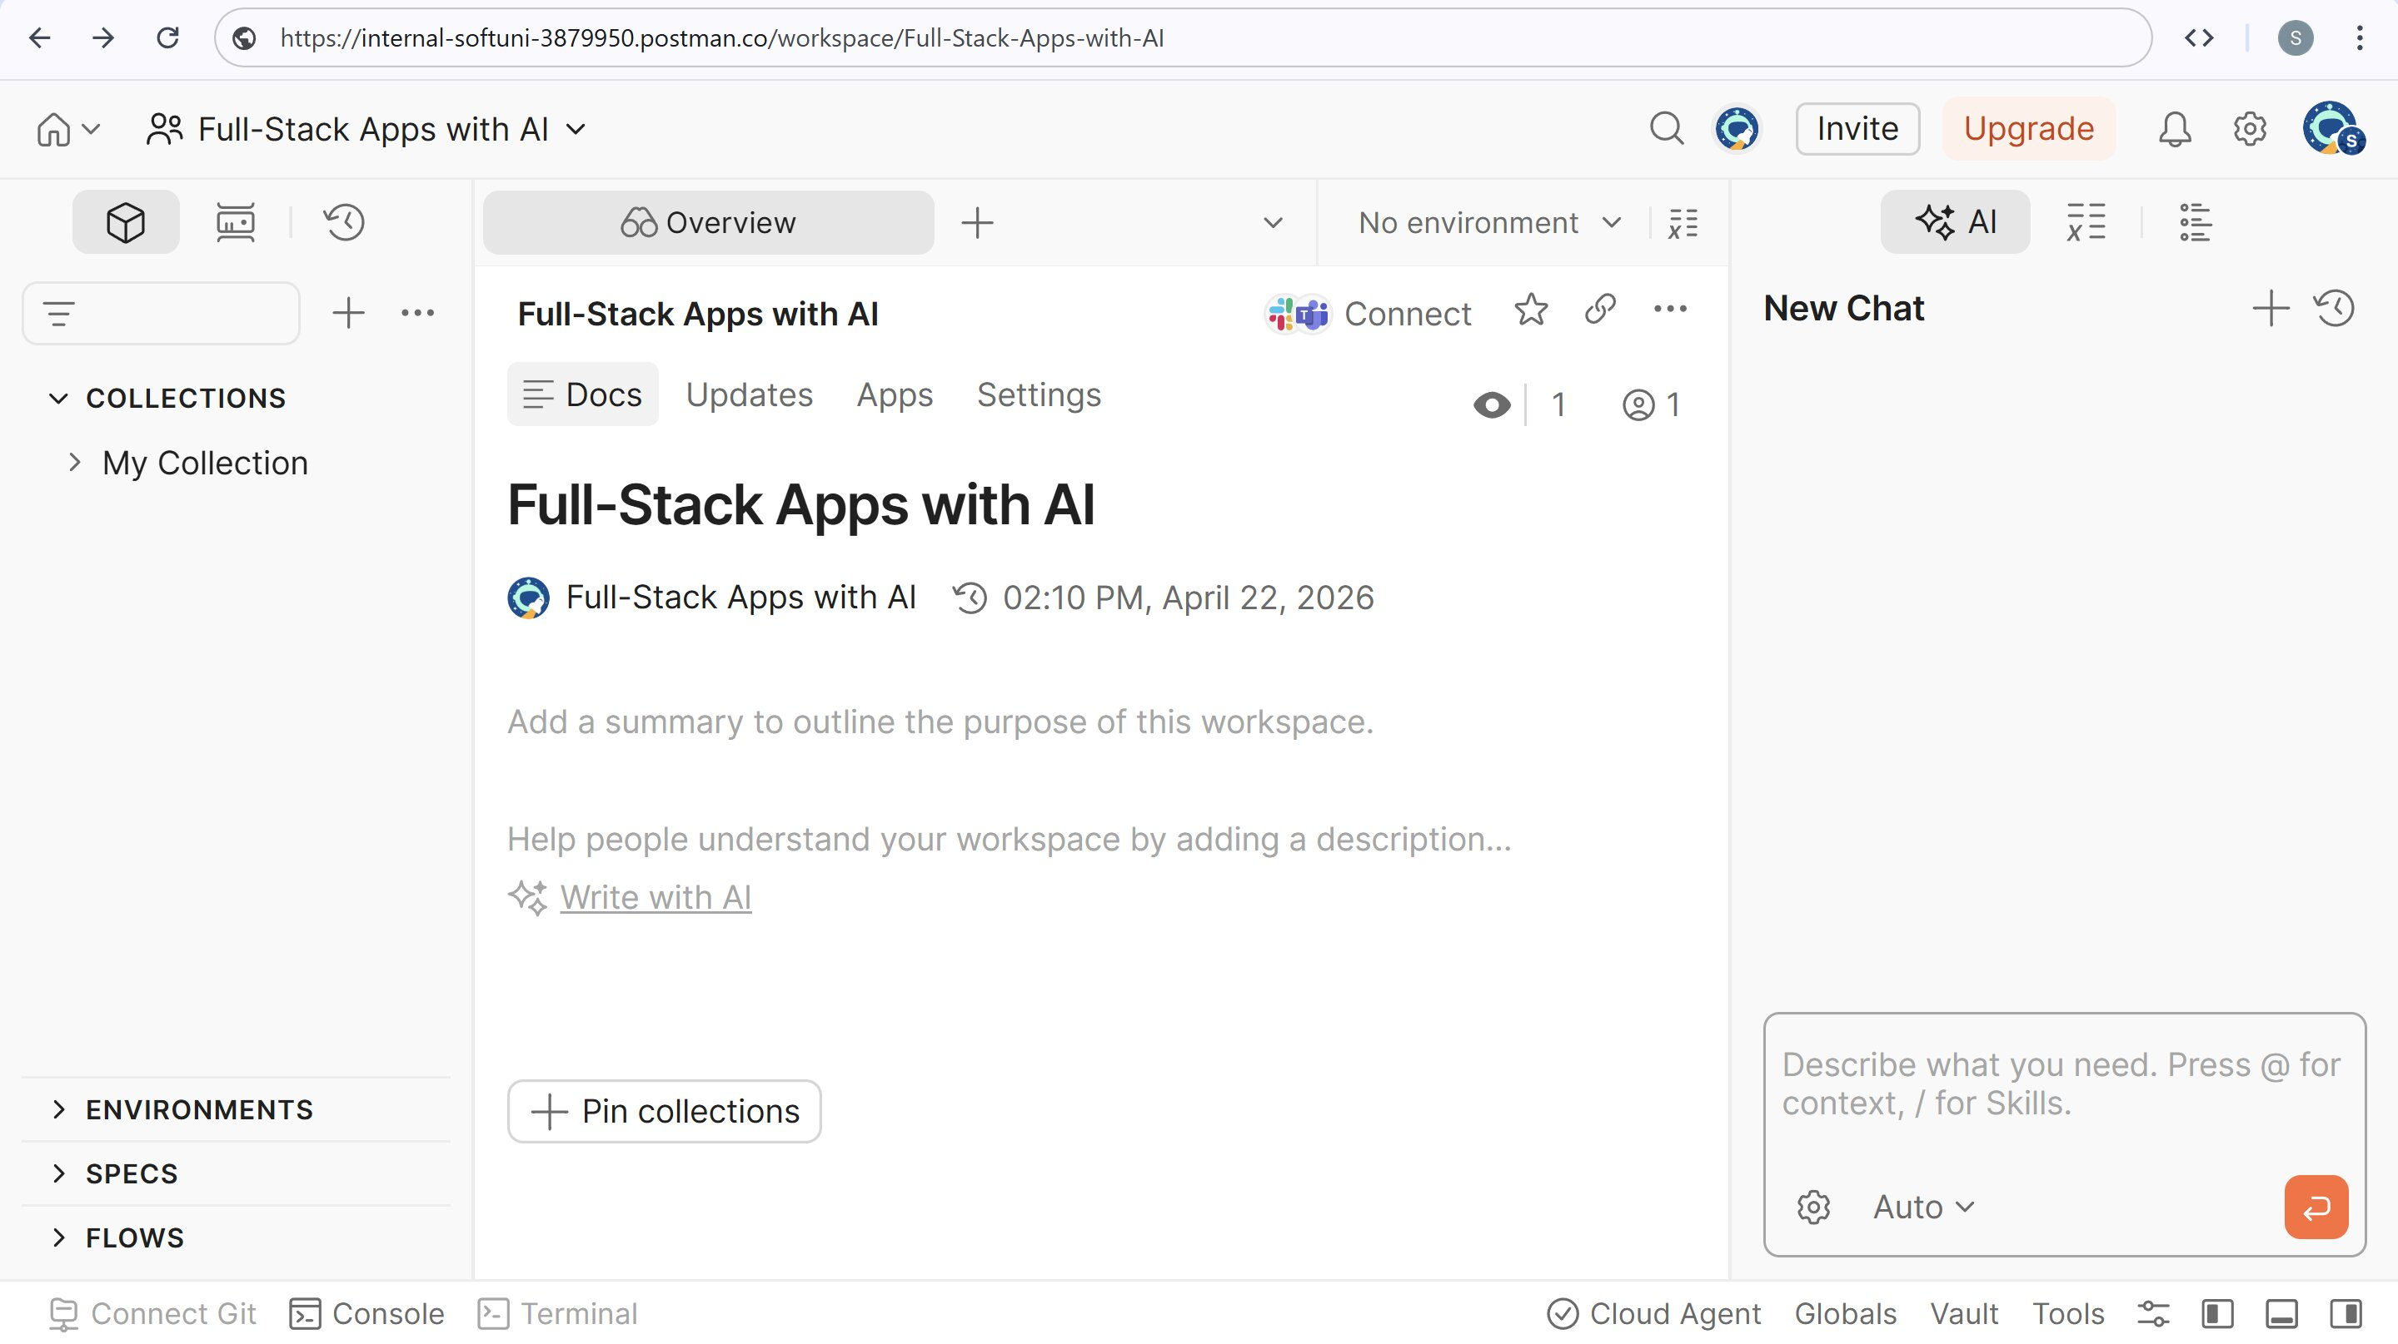
You can also download Postman as local desktop app for free from here: https://www.postman.com/downloads.
The workspace will look like this in the local version:
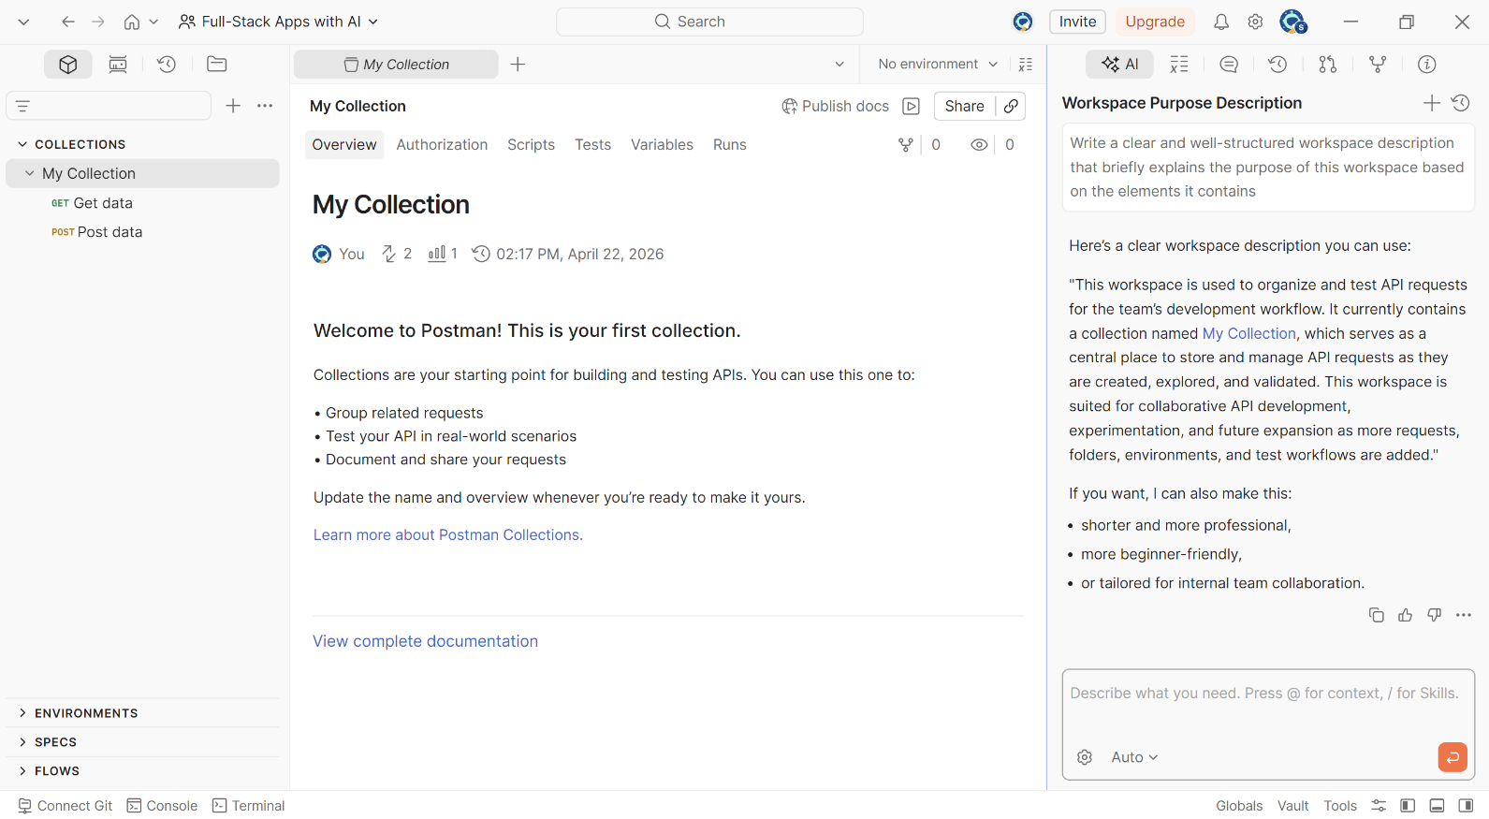

Minimalistic Jokes API
In a new workspace, build a minimalistic Jokes API with Next.js:
- Keep app data in a simple JSON file (no database)
  - Jokes have: id, title, text, publish date
  - Initially, load a few sample records
- Implement the following API operations (without authentication):
  - Get a random joke
  - List all jokes
  - List latest N jokes
  - Publish a new joke
  - Edit a joke
  - Delete a joke
- Generate a small home page, which documents briefly the API endpoints

Sample AI Prompt
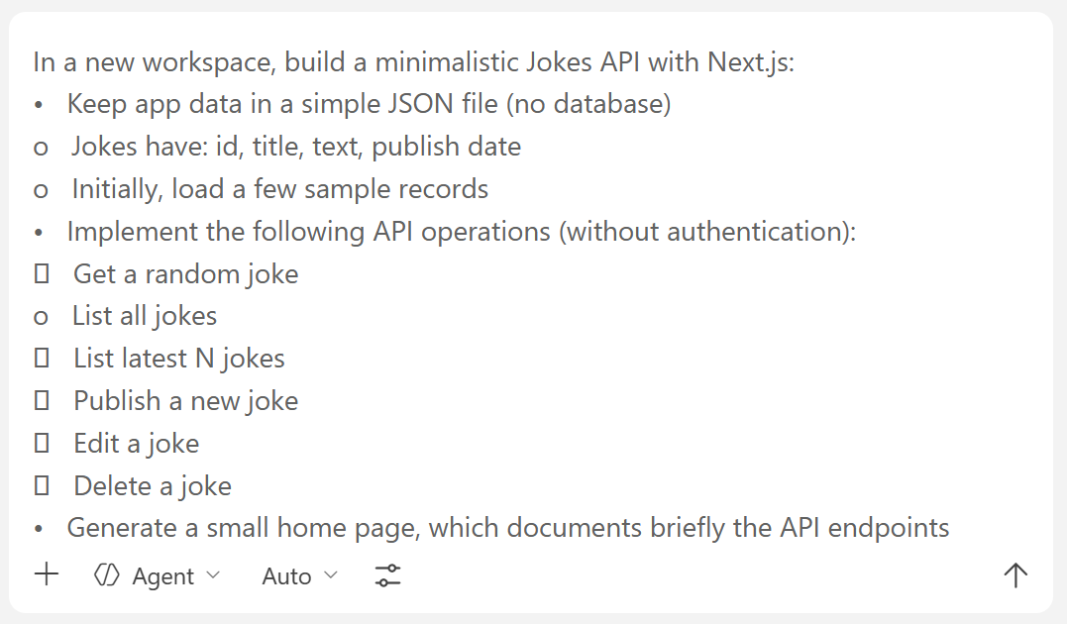

The API Documentation Homepage
If you want to see the documentation, run the `npm run dev` command in the VS Code Terminal:
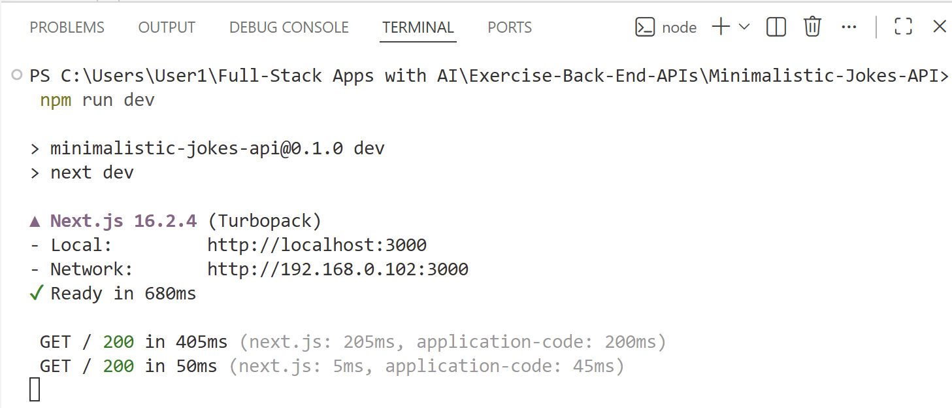
The documentation may look like this:
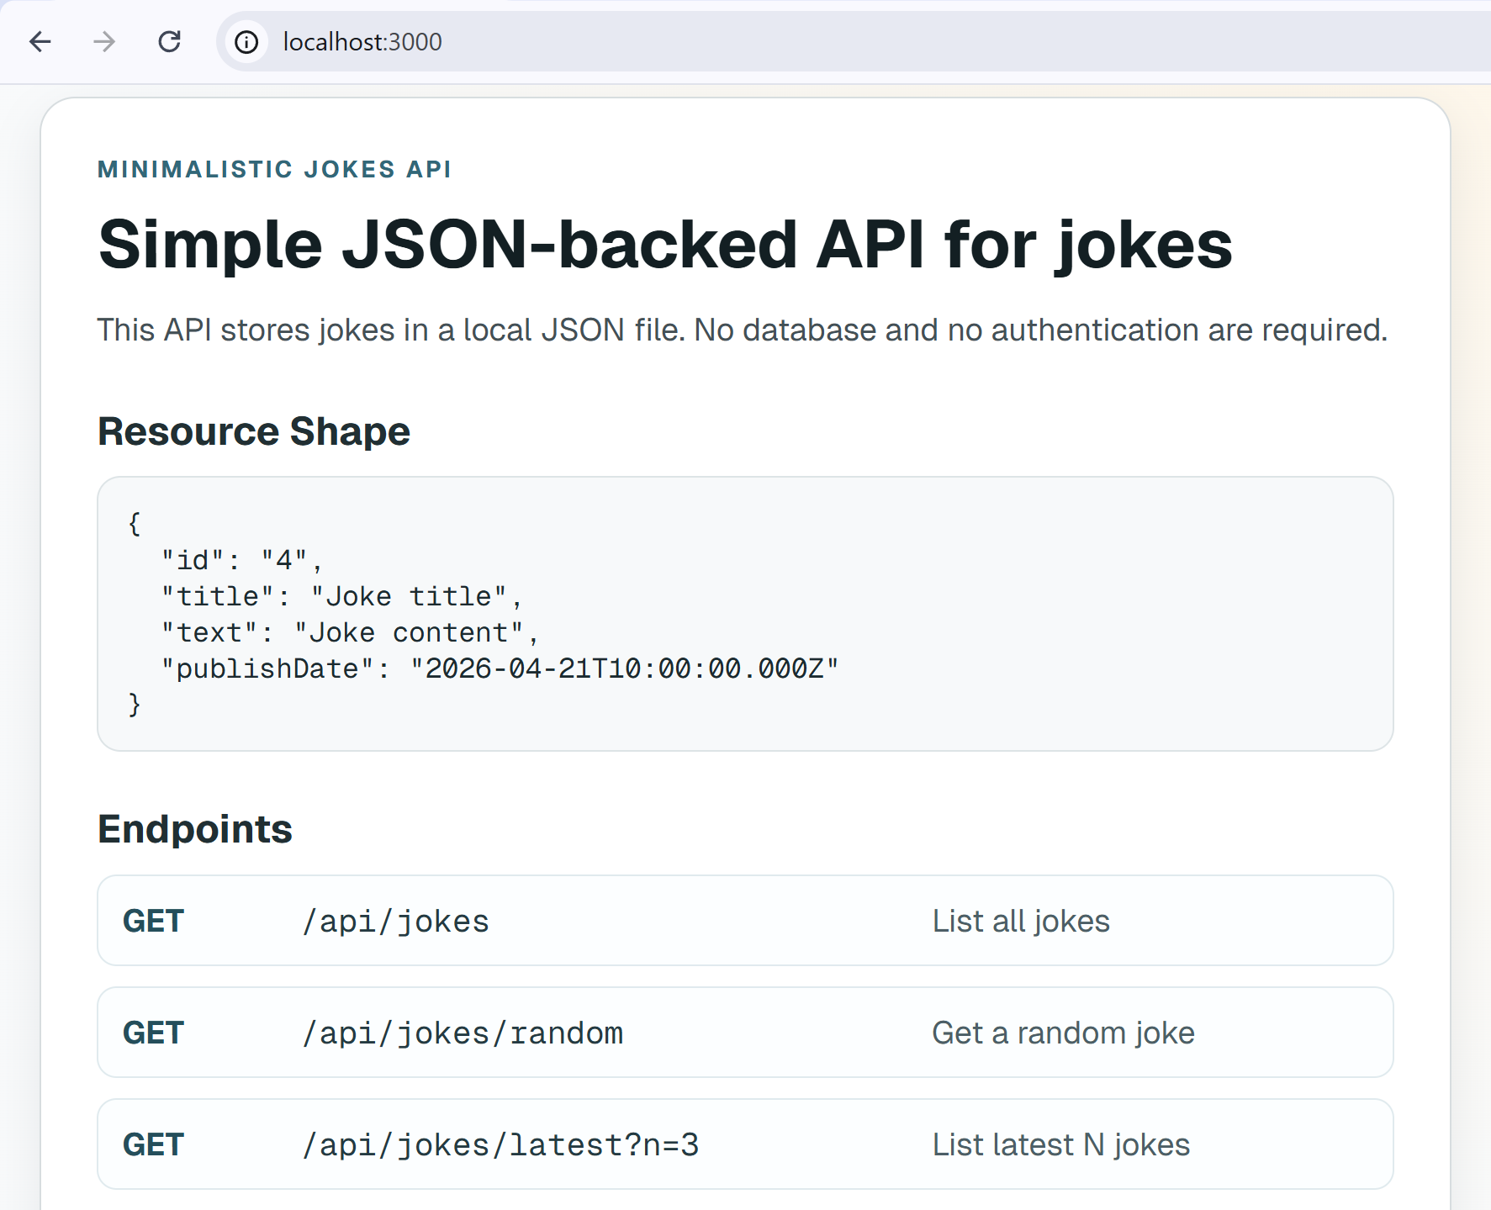

Test the API Endpoints with Postman
In Postman, the workspace is like a folder for a team or a big project. In this case it’s this course (Full-Stack Apps with AI). The separate exercise tasks are going to be organized in collections (Lecture 01 - Jokes API, Lecture 01 - Bookmarks API).
Notes:
- To test the API endpoints, you need to have active deployment. e.g. http://localhost:3000.
- Do not put more than one project into one collection.
- Take the endpoints for the tests from the documentation on the website
To create a collection, click the [+] button in the left sidebar and then select [Collection]:
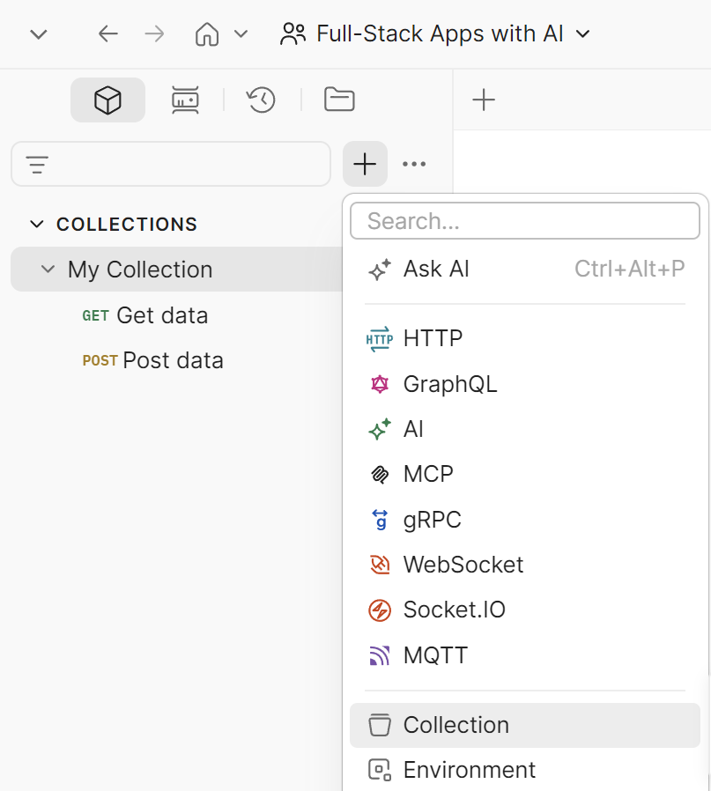
When you have created the collection for this task, click the collection and then [Add folder]:
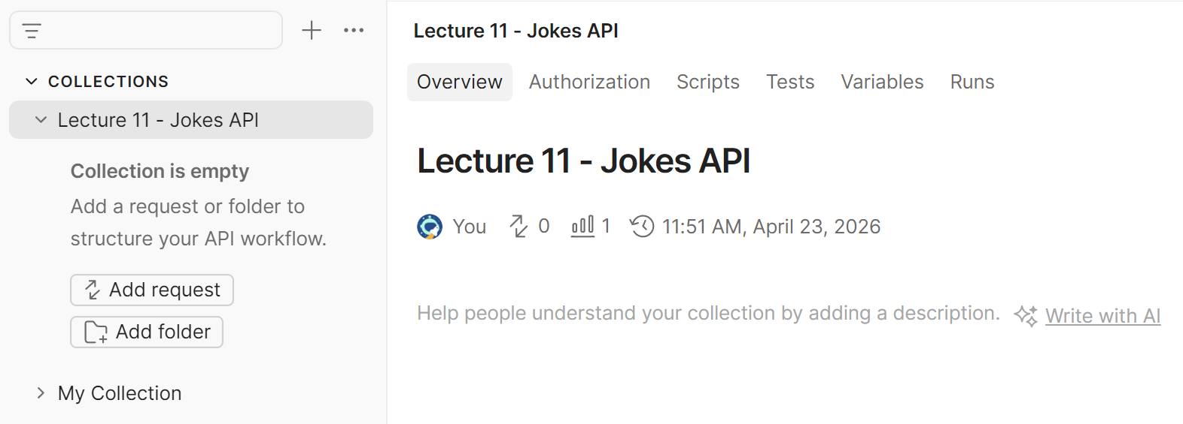

GET Request
Then rename the folder `GET` by clicking the title:
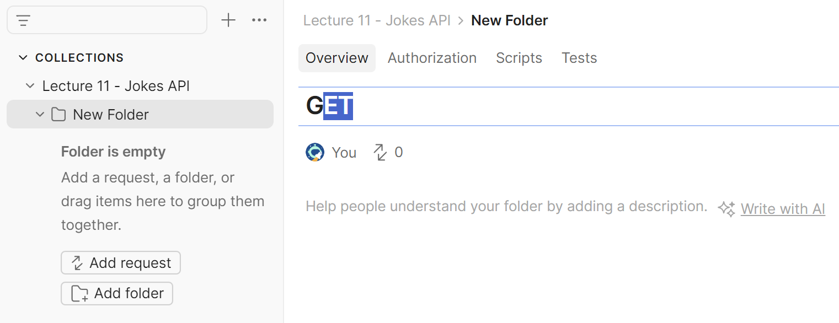
Then open the new folder and click the [Add request] button.
Rename the new request with specifications on what is being tested. In the sample case below, it’s a simple GET request to display all jokes:
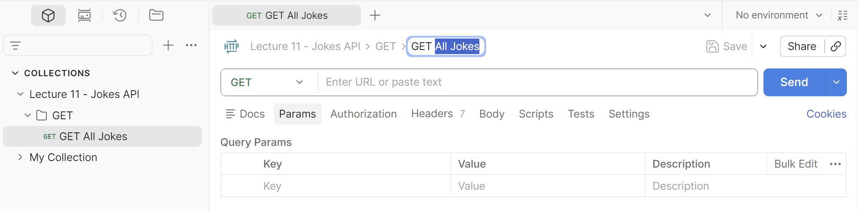
Then enter the URL for testing and click the [Send] button.
If your API is working, you should get code 200 OK:
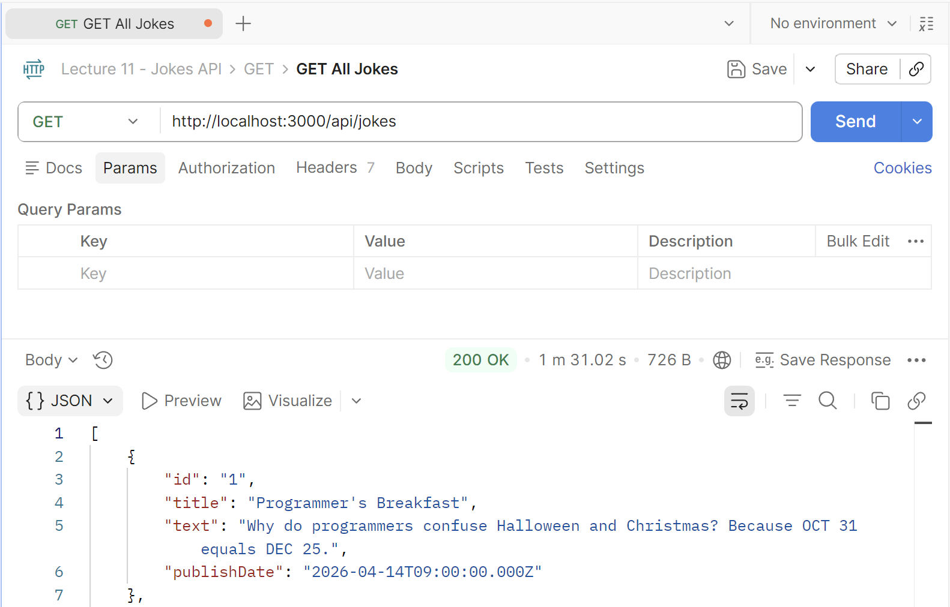
Then create a new request with the [+] button and continue testing the GET request:
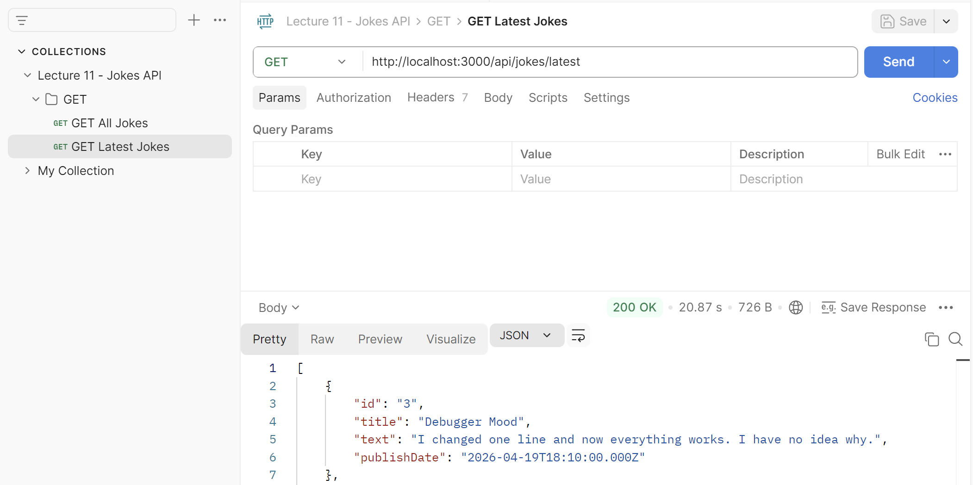
When you are done with testing the GET request, create a new folder and test another request (e.g. POST).

POST Request
Ask Copilot to generate you a random joke in JSON format to add to the jokes already generated. Your prompt and response may look like this:
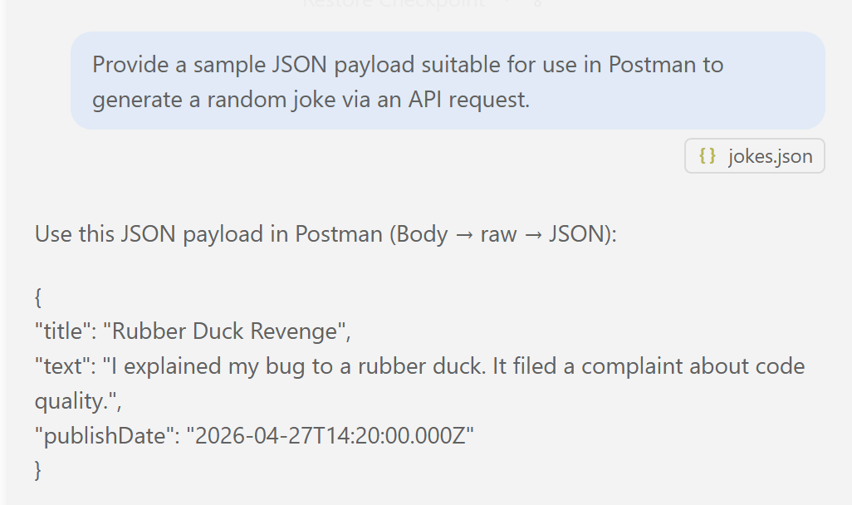
In Postman, use the folder you created for the POST requests and click the [Add request] button to save the request and the future results from it.
Paste the http://localhost:3000/api/jokes in the request tab. Then click the [Body] button and from the drop-down menu select [raw]:
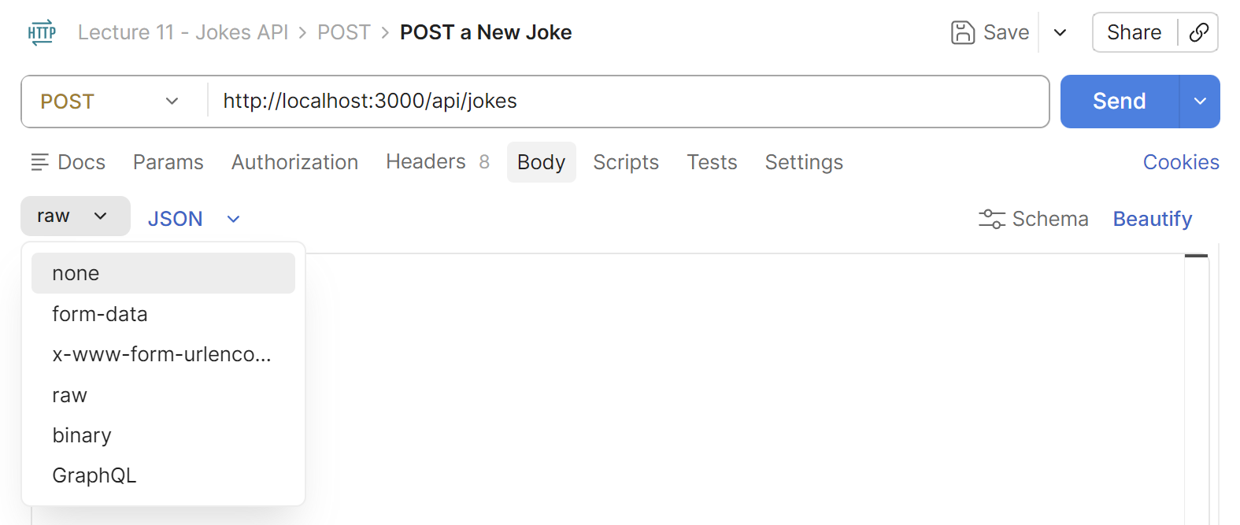
Next to the drop-down menu select [JSON] as a format. Paste the JSON code from Copilot:
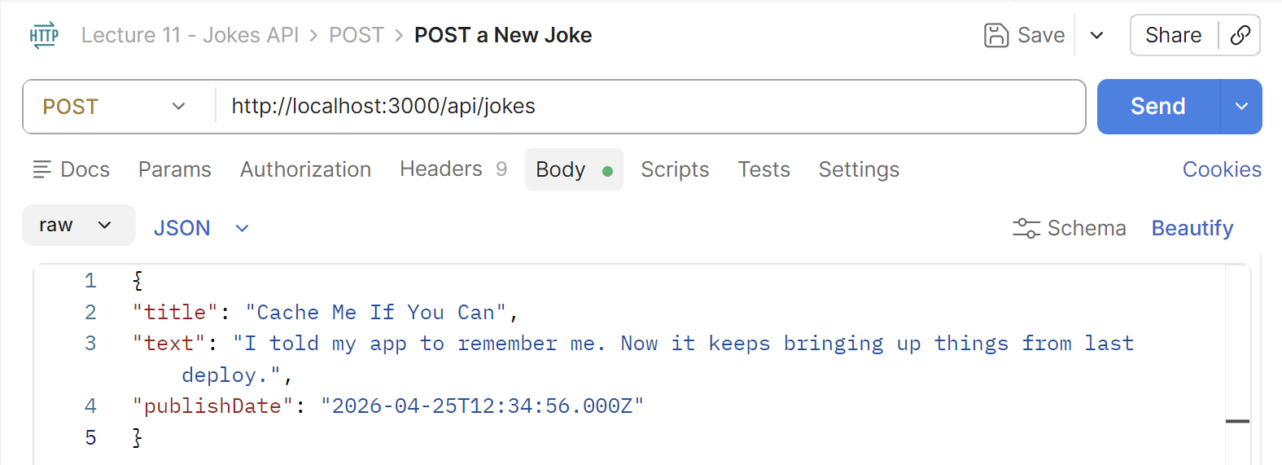
This is what you should get if the joke has been created – the joke body with an id and a [201 Created] confirmation code:
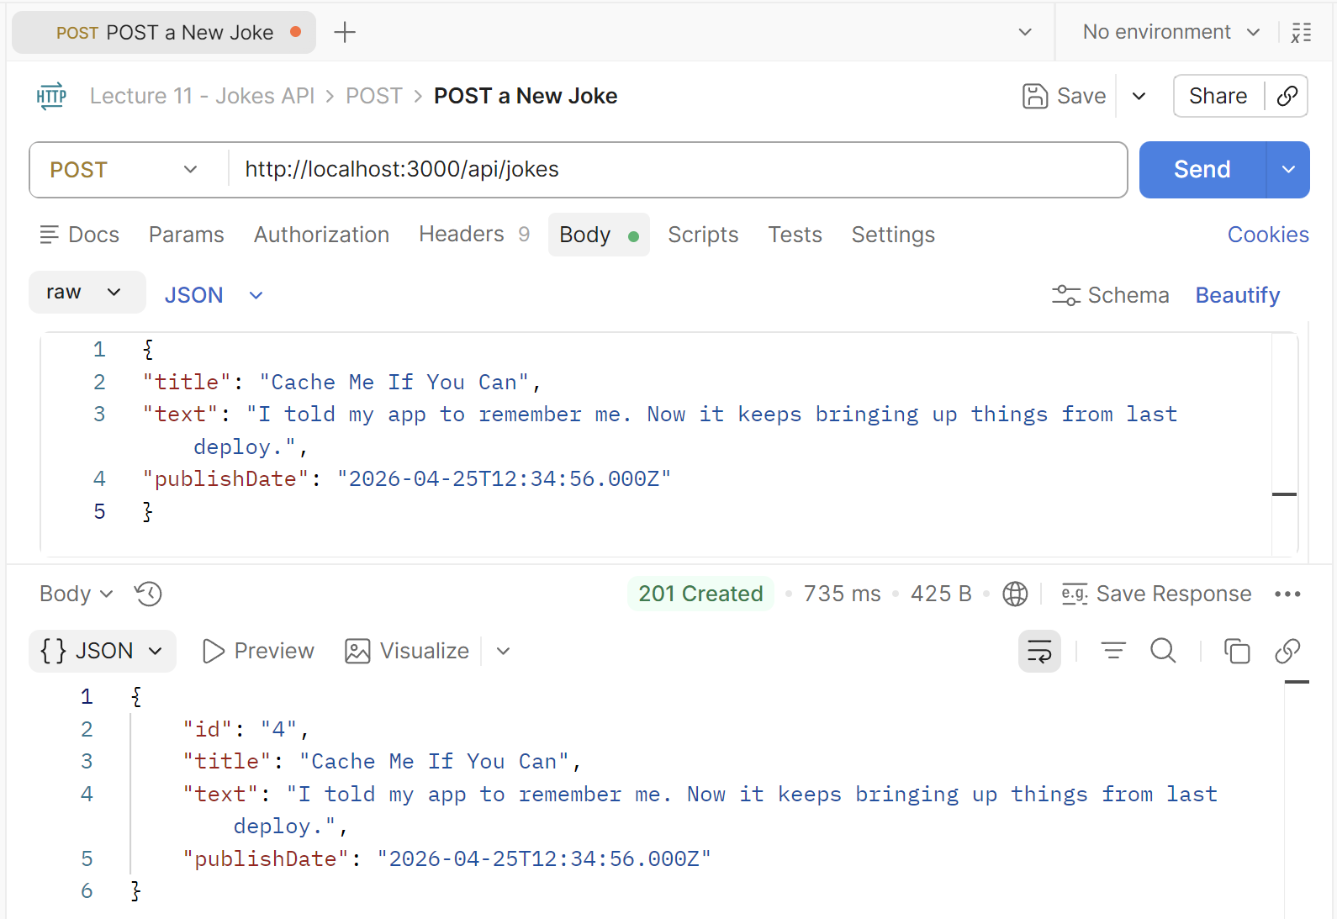

Bookmarks Next.js API with Auth
In a new workspace, build a minimalistic Bookmarks API with Next.js and TypeScript:
- Implement auth API endpoints: user register / login / me / logout
- Implement CRUD operations for the user's bookmarks as protected endpoints (with JWT auth)
  - Each user can access only own bookmarks (after auth)
  - Implement paging (to handle large datasets)
- Keep app data in a simple JSON file (no database)
  - App users have: email, password (encrypted)
  - Each user has own bookmarks
  - Bookmarks items have: id, URL, description (optional), date created
  - Initially, load sample data (users + bookmarks, enough records to demonstrate paging)
- Generate a small home page, which documents briefly the API endpoints
- Deploy the app to Netlify

Sample AI Prompt
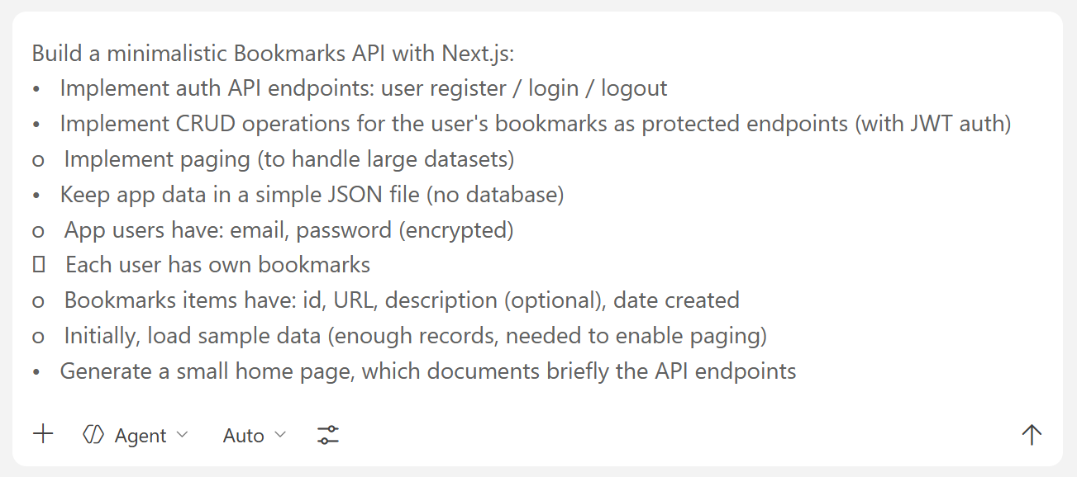

The API Documentation Homepage

Title and Details Section
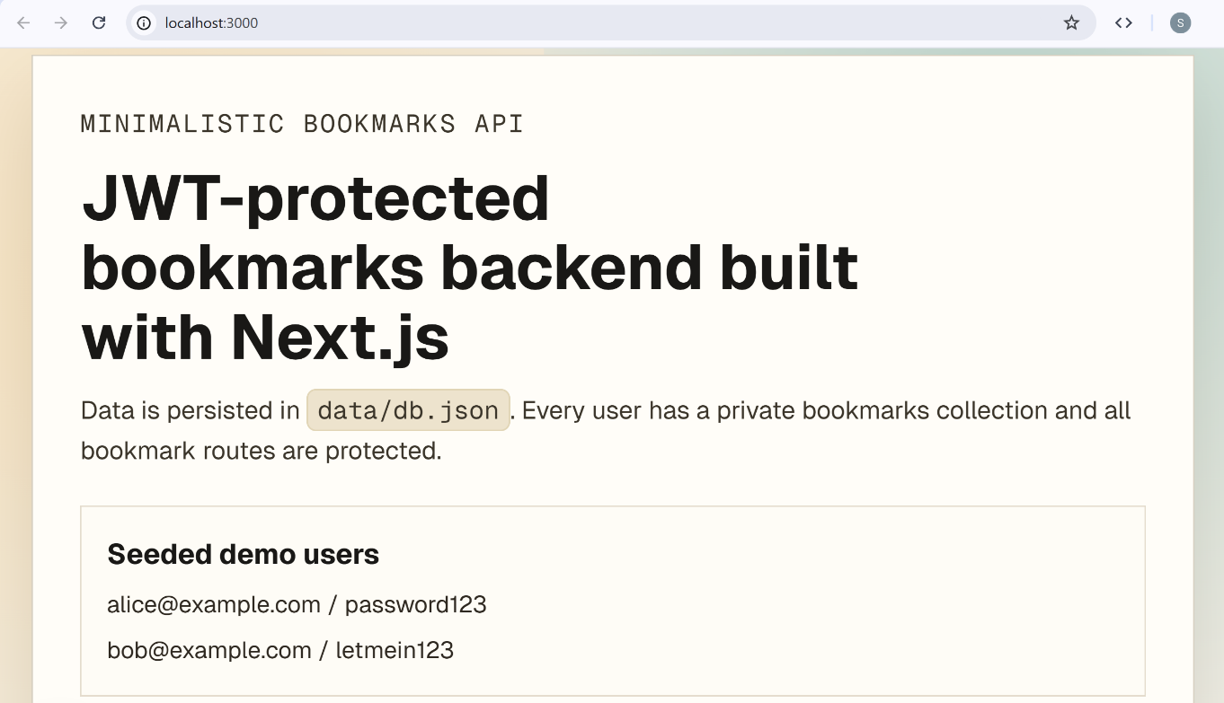

Endpoints Section
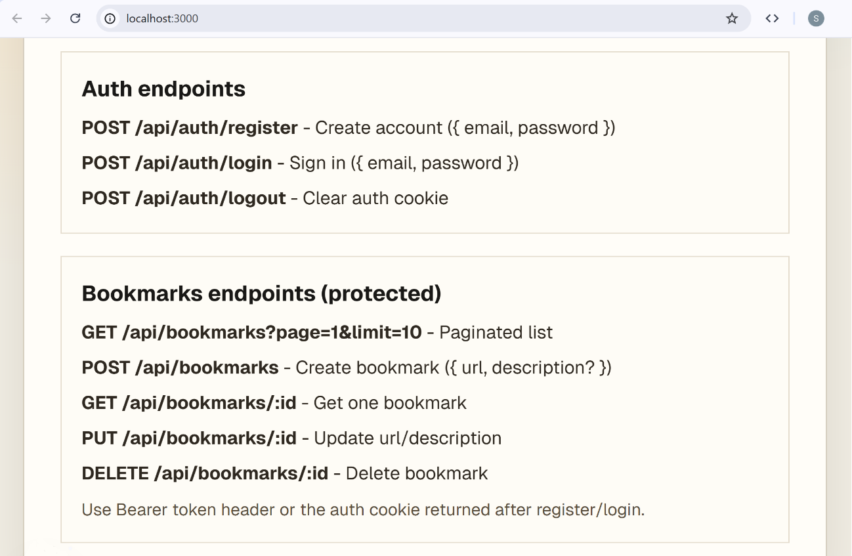

Testing the API Endpoints

Step 1: Organize Postman
Create a new collection – [Bookmarks API]. Then create two folders – [Auth] and [Bookmarks]. Add a new request and name it [Registration].

Step 2: Test Registration
Ask Copilot to generate JSON request body for the test:
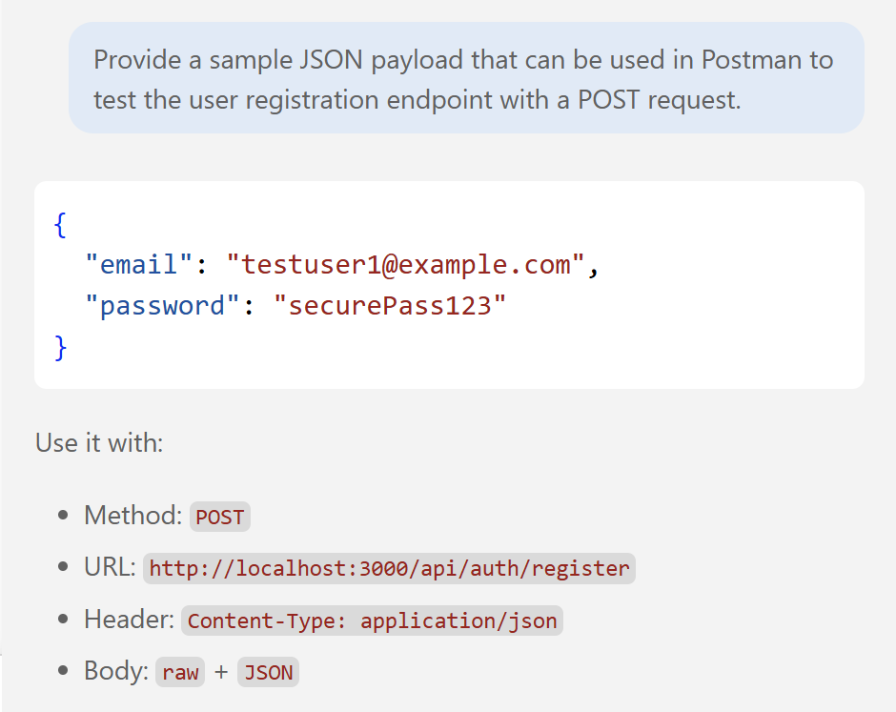
The method is a POST request. In the URL space put the local server URL + the registration API endpoint from the documentation.
Select [Body], then [raw] and JSON as a format. Paste the JSON request body from Copilot:
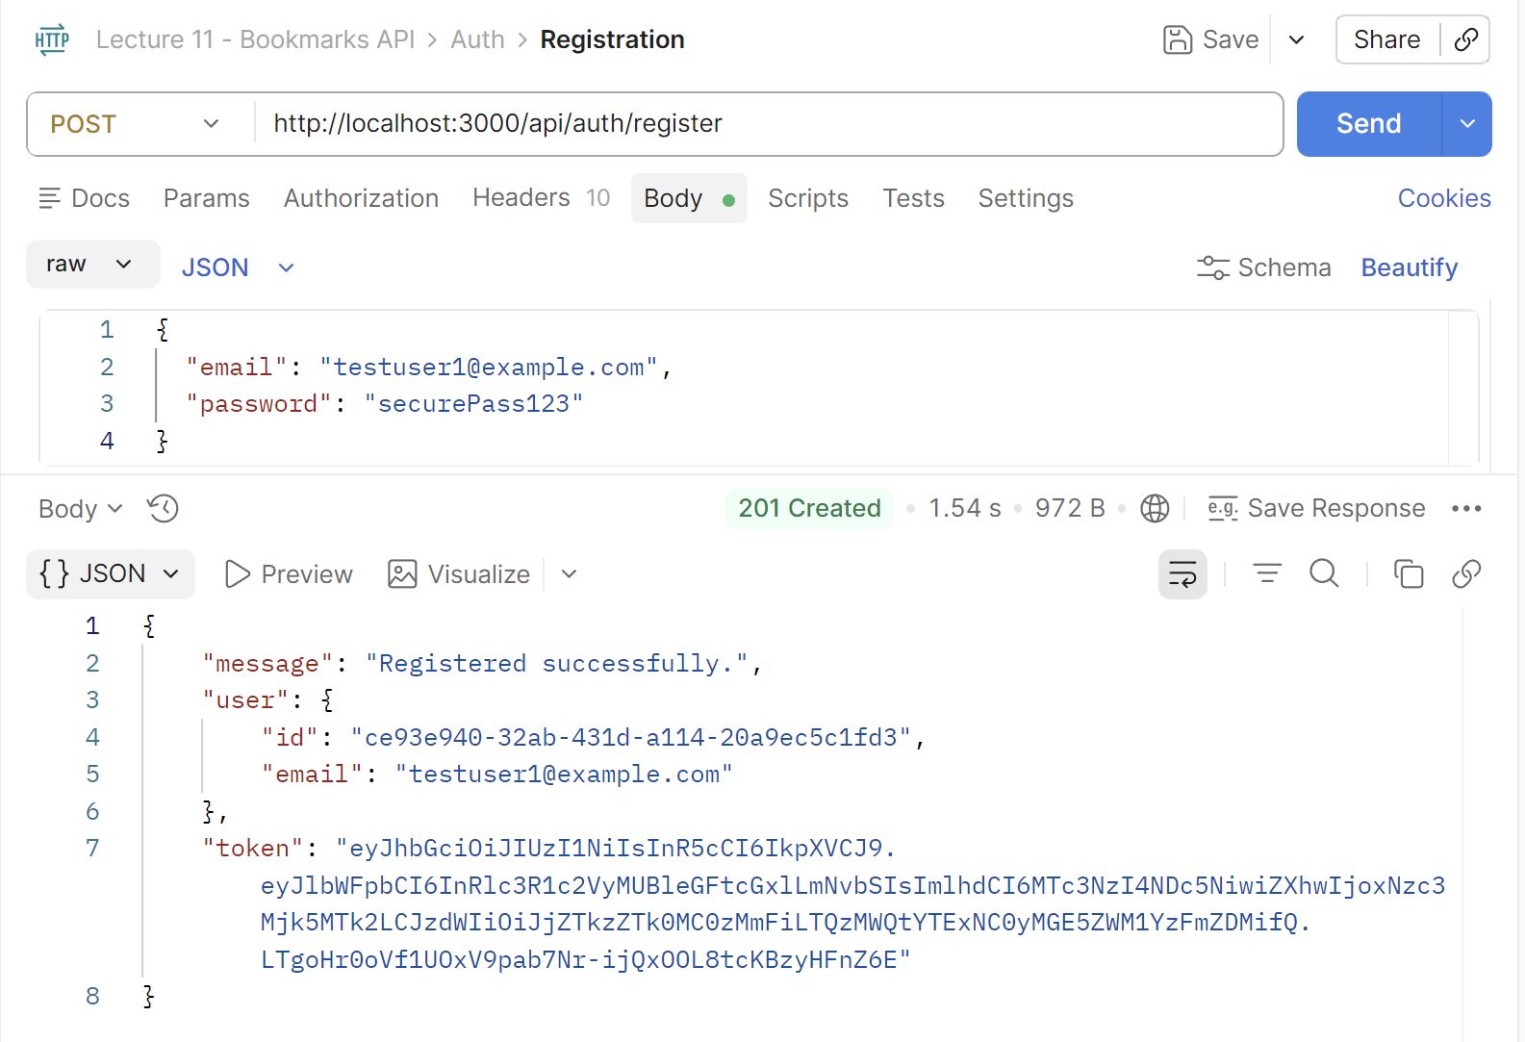

Step 2: Create a Bookmark for a User

Log a User In
Create a new POST request in the Auth folder and name it "Login". In the URL space put the local server URL + the login API endpoint from the documentation.
Follow the process from the previous tests. In the [Body] section put the following request body with the credentials of the user that was registered during the previous step or some of the seeded sample users:
{
"email": "testuser1@example.com",
"password": "securePass123"
}
Expect to get a confirmation code [200 OK] and a token. This token is very important and is unique for every user:
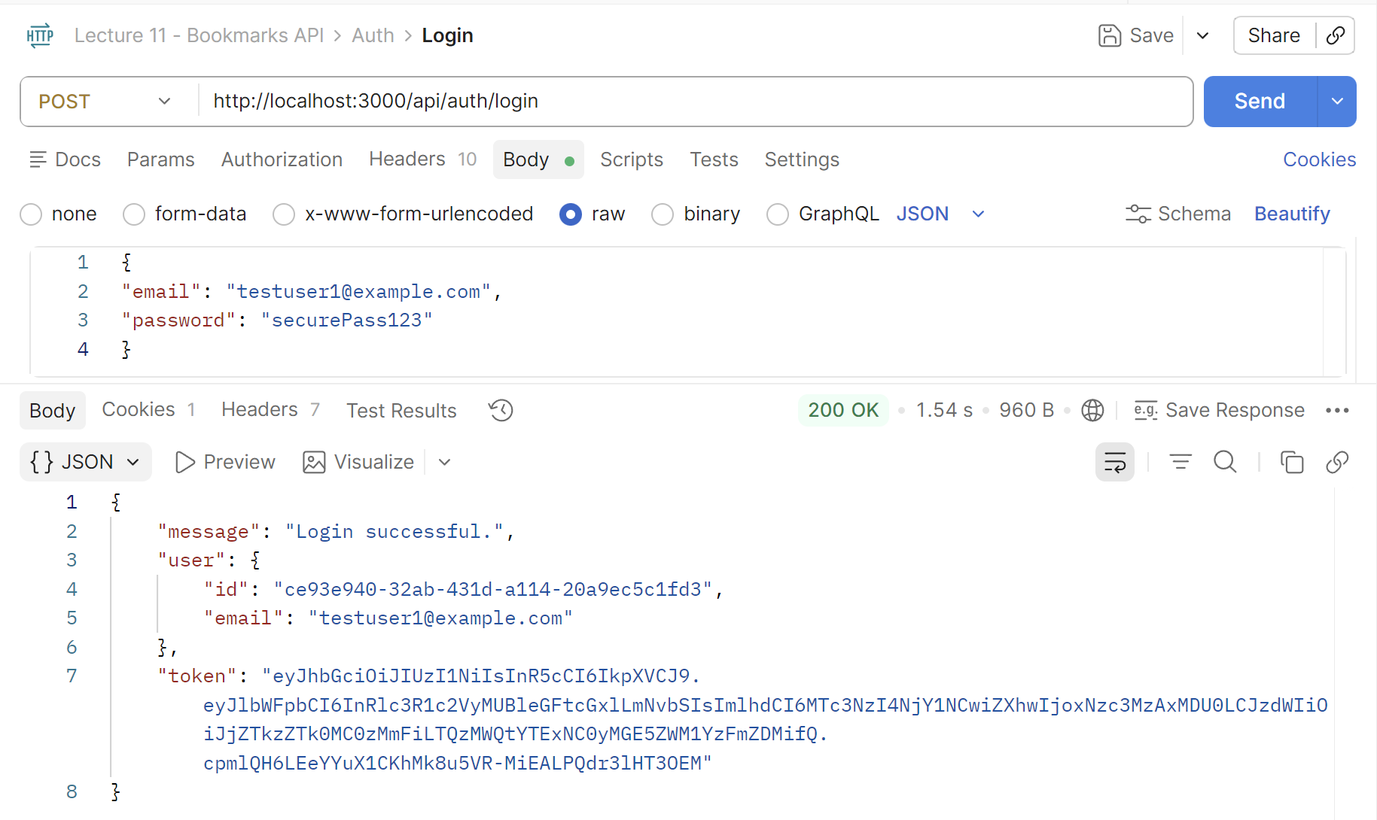
Copy the token. Go to the [Authorization] tab, select [Bearer token] as type and paste the token there:
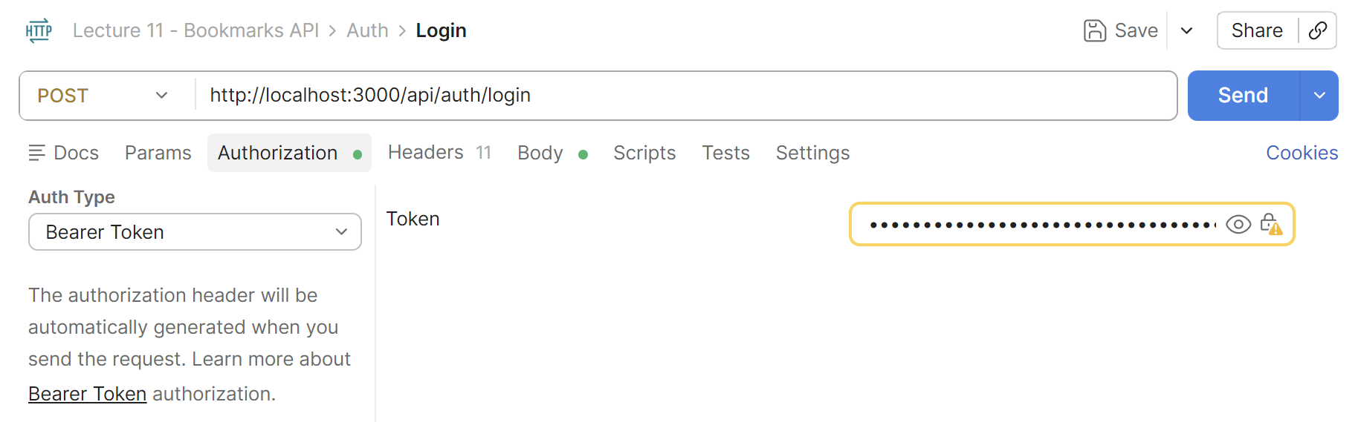
Now all requests that fill follow will be for this specific user logged in.

Create a Bookmark
Create a new POST request in the Bookmarks folder and name it "Create a Bookmark". In the URL space put the local server URL + the creating bookmarks API endpoint from the documentation.
Follow the process from the previous tests. In the [Body] section put the following request body with a link to save as a bookmark and a name for saving. You can put whatever link you want:
{
"url": "https://google.com",
"description": "Search engine"
}
This is the expected message:
Note: This bookmark is for the user that was registered and logged in during the previous steps.
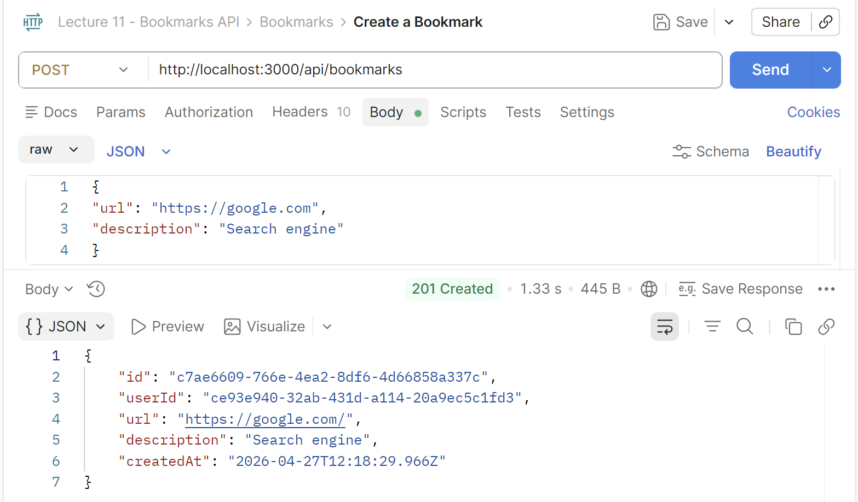

Step 3: Test Security

Testing Logged in User
Use a GET request to see all bookmarks. It is expected to get [200 OK] and see the bookmark from before:
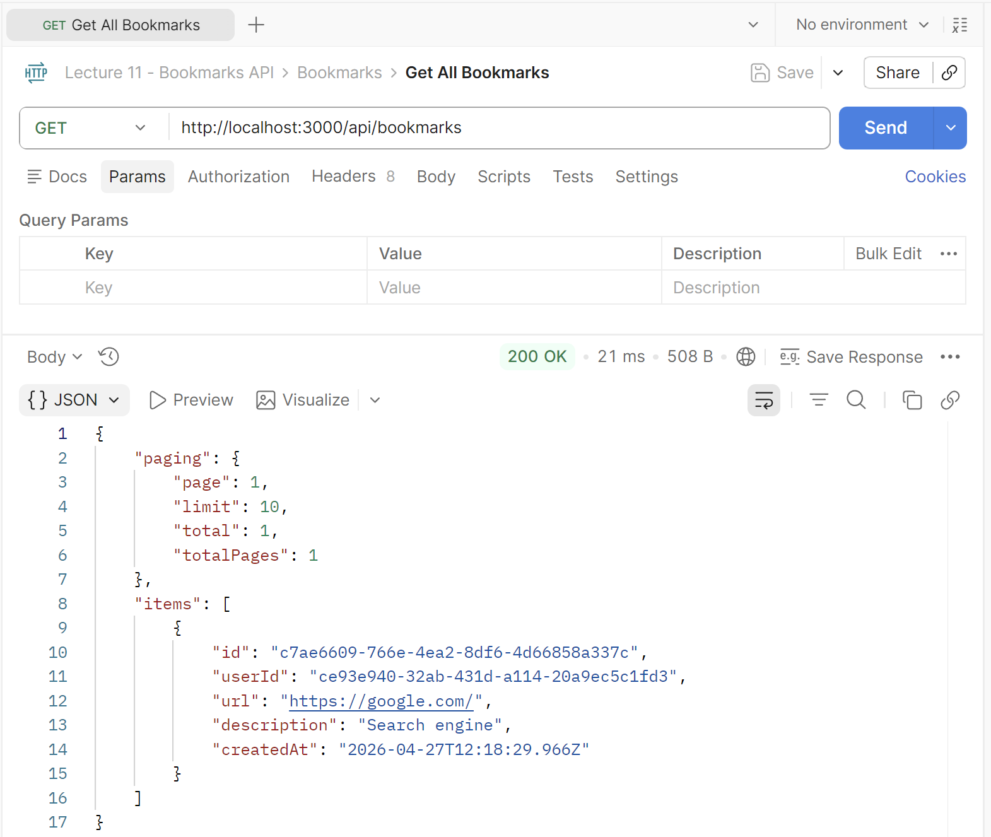

Testing without a Logged in User
Click the [Authentication] tab again and remove the token from earlier. Now there is no logged in user.
Repeat the GET request for all bookmarks. This is the expected behavior – getting a [401 Unauthorized] message:
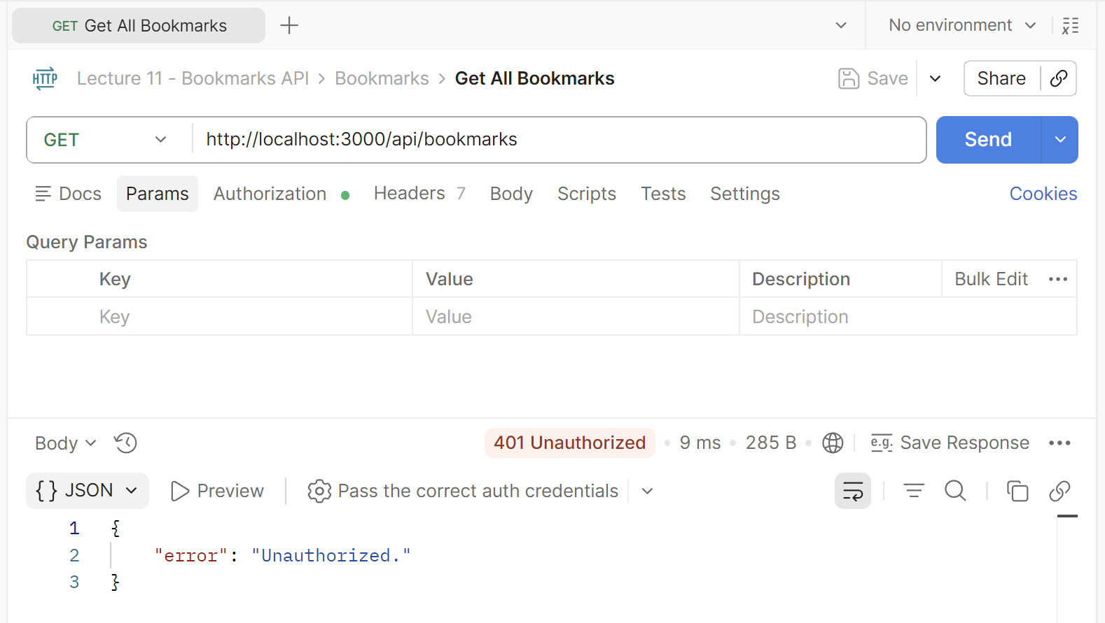

Possible Error and Solution
If, after removing the token, you still get [200 OK] there might be two possibilities:
Error in the code
Ask Copilot to review the code for possible security issues.

Postman Cookie Jar
The reason you can access bookmarks without explicitly sending a token is that the auth cookie is being sent automatically.
When you registered or logged in, the response set an HTTP-only cookie (bookmarks_auth_token) in your browser or Postman's cookie jar. Every subsequent request to the same origin silently includes that cookie, so the auth check passes - you do have a token, it's just invisible in the cookie header.
Solution
Open Postman’s Settings and disable the cookies:
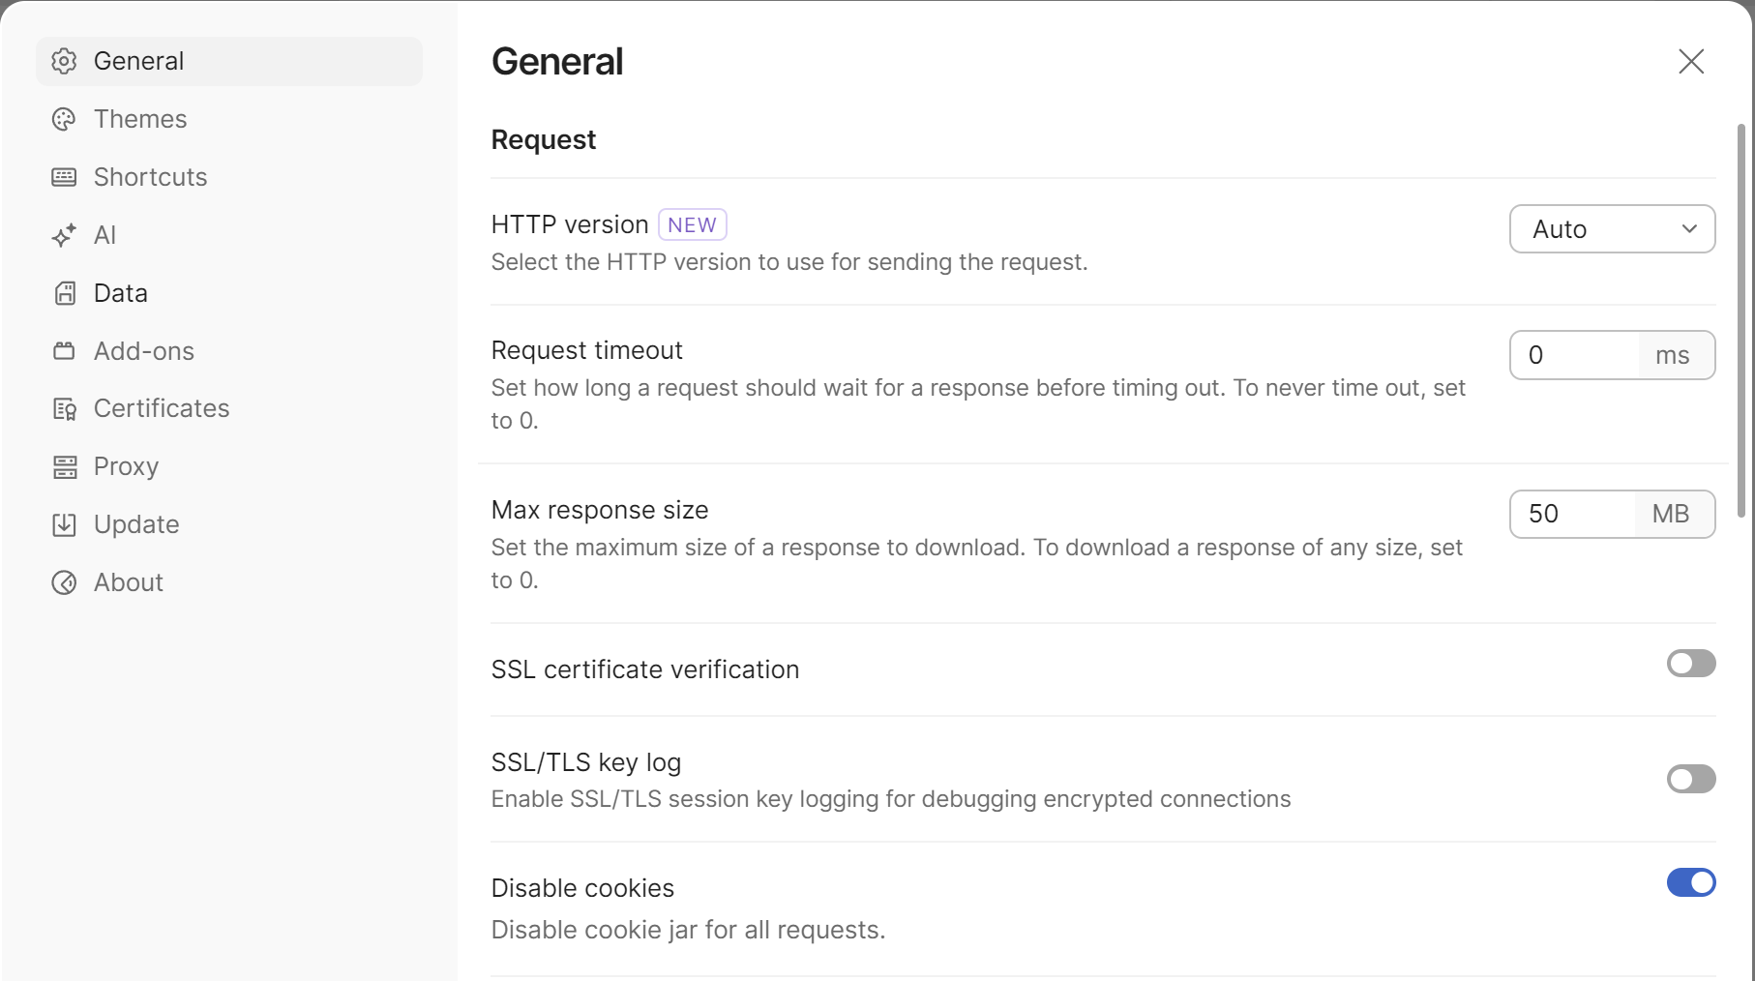

Bookmarks Client App with Auth
Create a minimalistic Bookmarks client app: implement register / login, view / add / edit / delete bookmarks.
- Use the existing Next.js API with authentication
- Add a link to the API docs page (instead of deleting it)

Sample AI Prompt
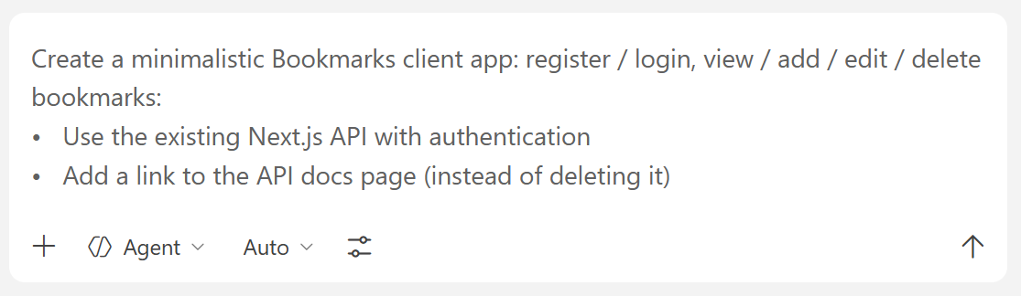
The Result
The Home Page
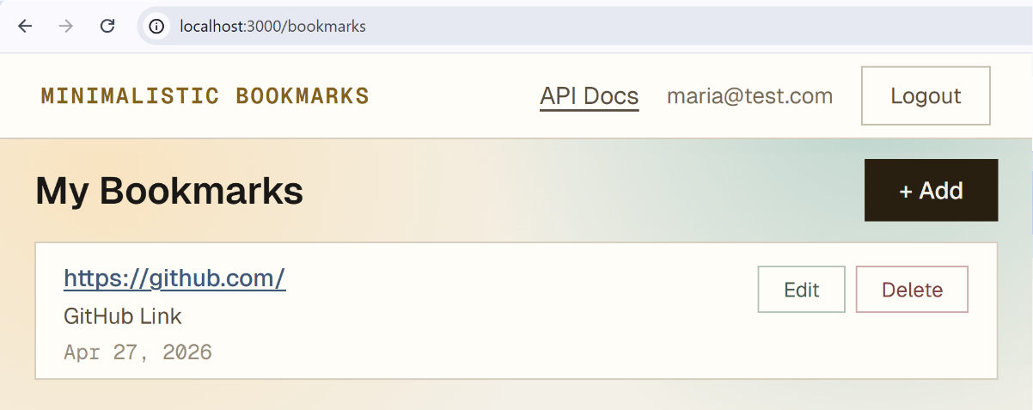

The Add Pop Up
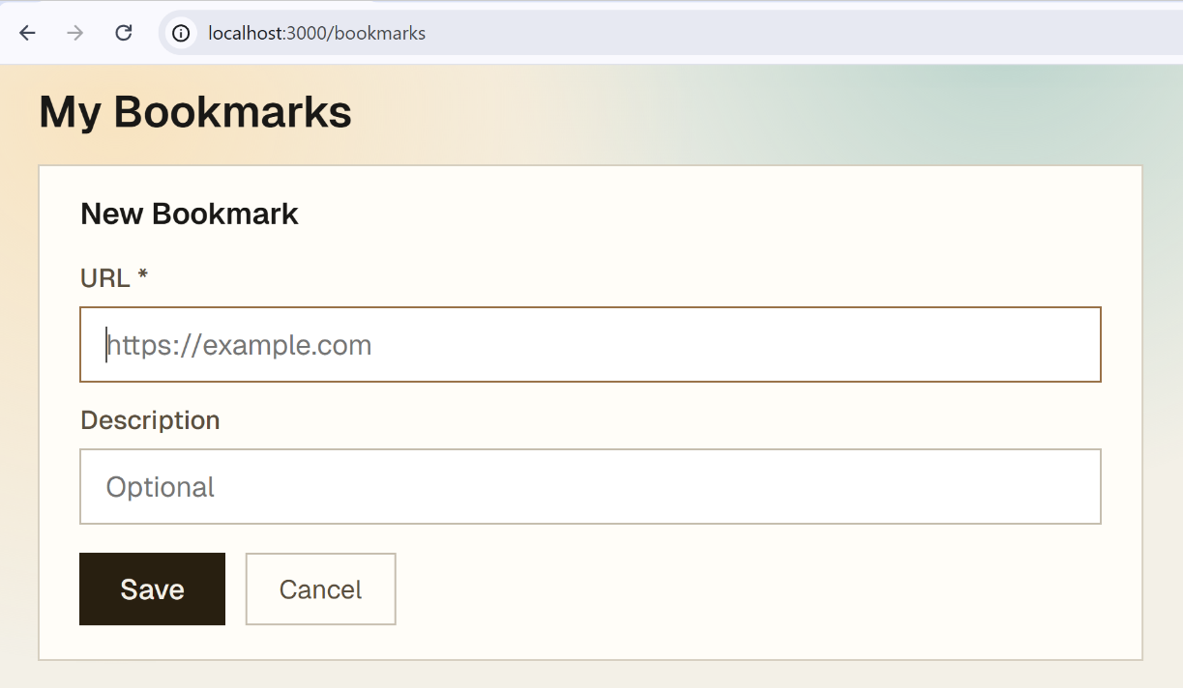

The Sign In/Register Field
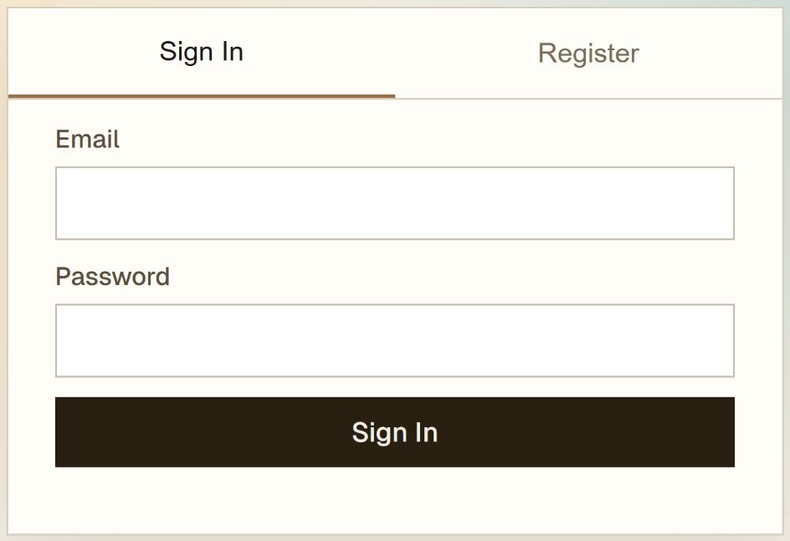

Bookmarks Admin
- Implement admin users in the Bookmarks API
  - Add `isAdmin` property for each user
  - The first admin will be created by hand, in the app's JSON storage
- Implement additional API endpoints for admins:
  - Manage the bookmarks of all users (view / create / edit / delete)
  - Manage users (create / edit / delete)
- In the client app implement Admin Panel in page `/admin` with the following tabs:
  - Manage Bookmarks in page `/admin/bookmarks`: view / create / edit / delete bookmarks
  - Manage Users in page `/admin/users`: view / create / edit / delete users
- After user login, display [Admin Panel] link for admin users

Sample AI Prompt
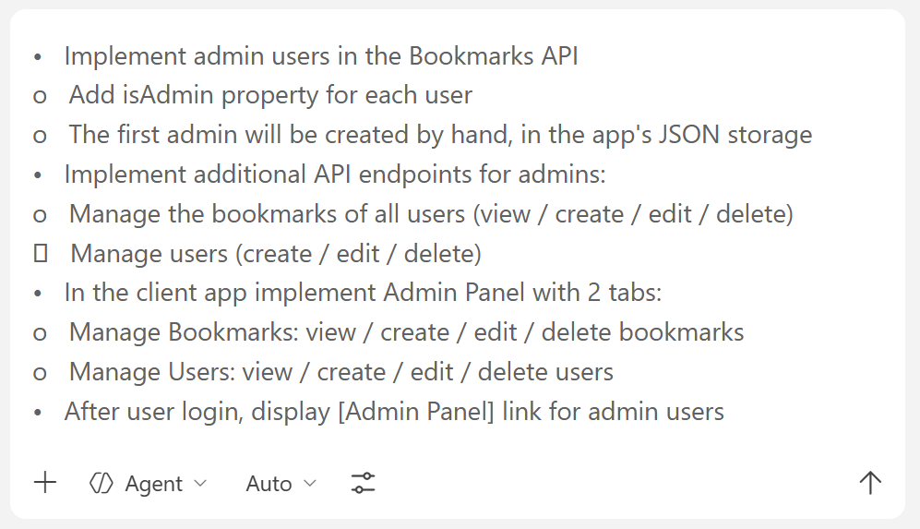

The Result

Bookmark Management
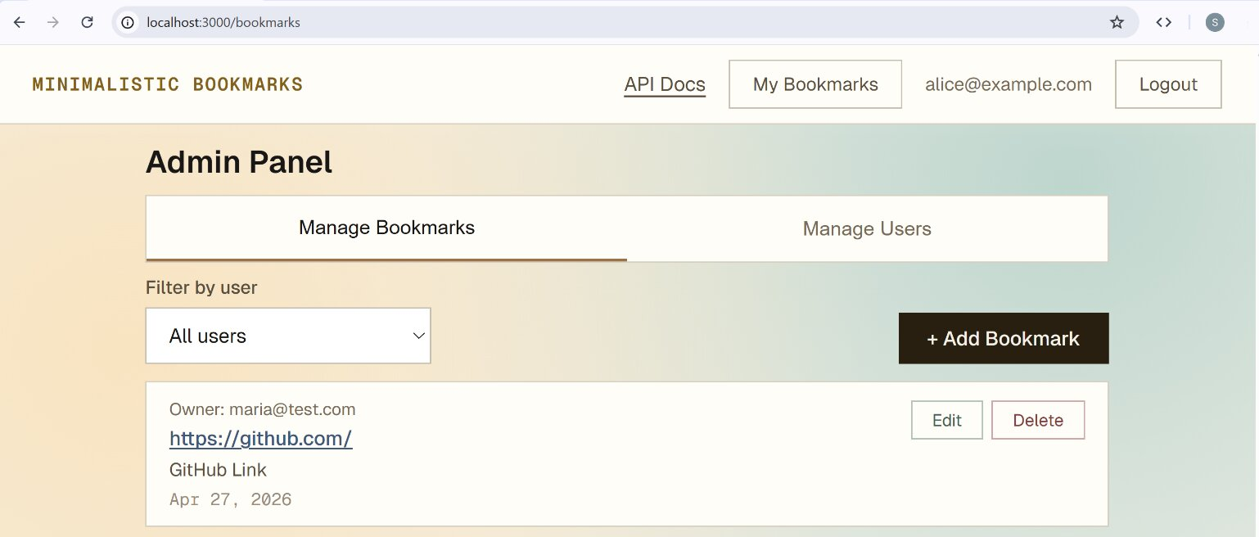
They can be filtered by users:
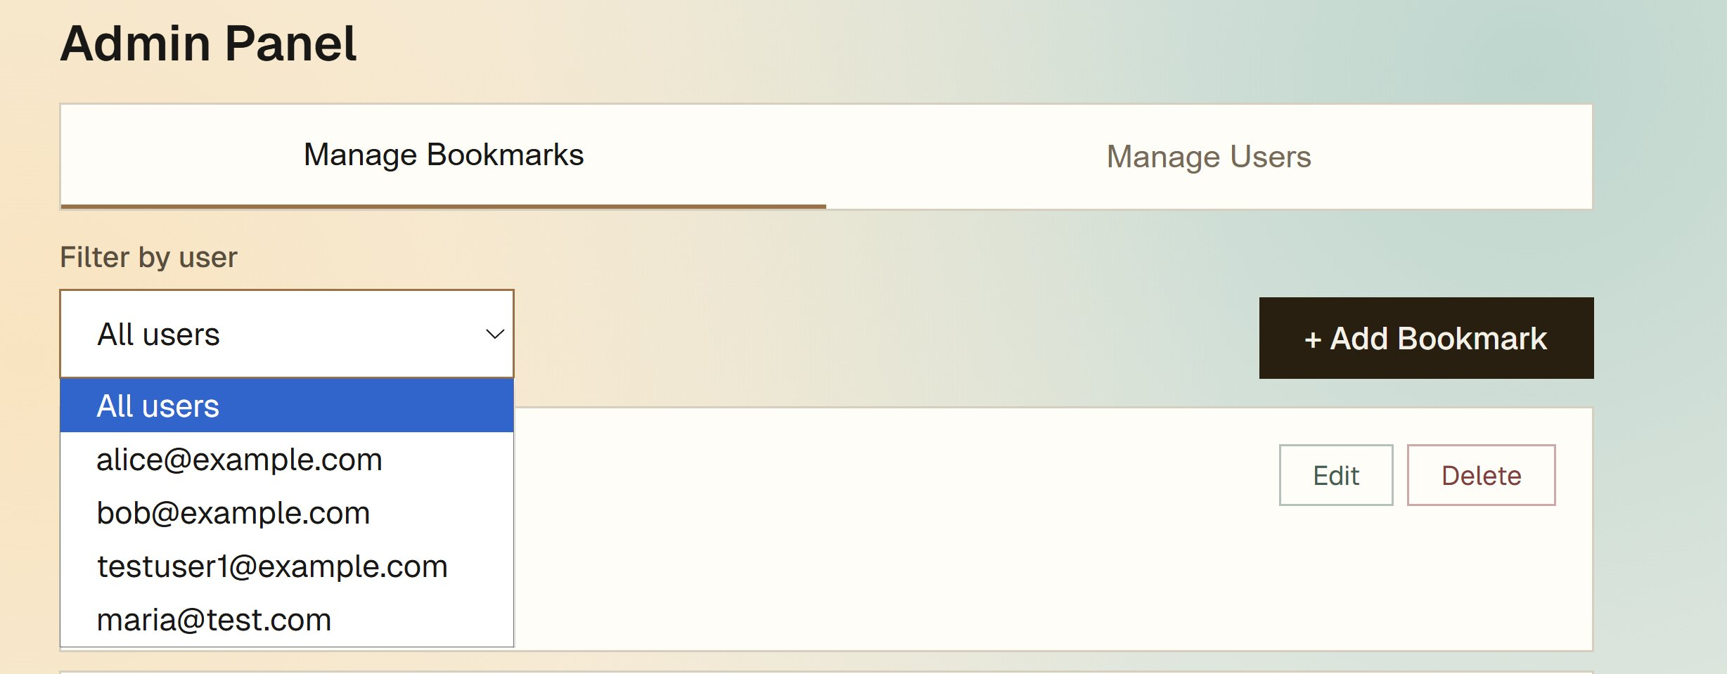

User Management
Admins can create regular users and give them admin rights.
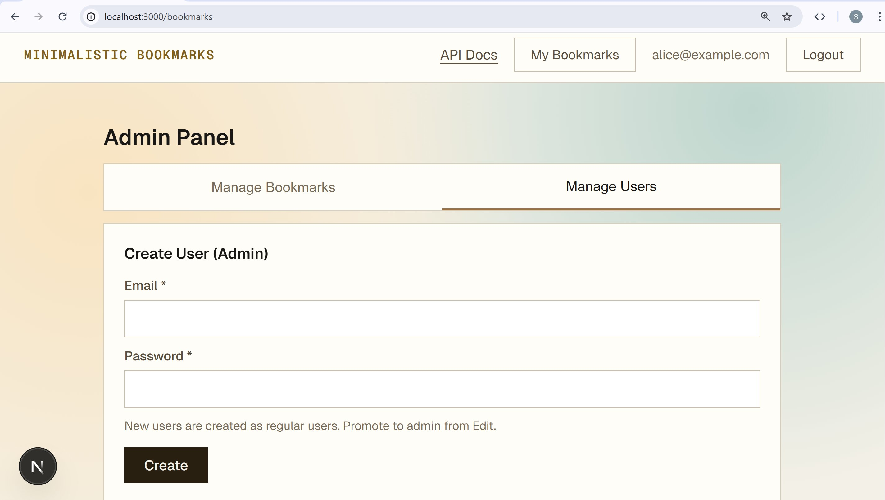
Or edit existing users and promote them to admins:
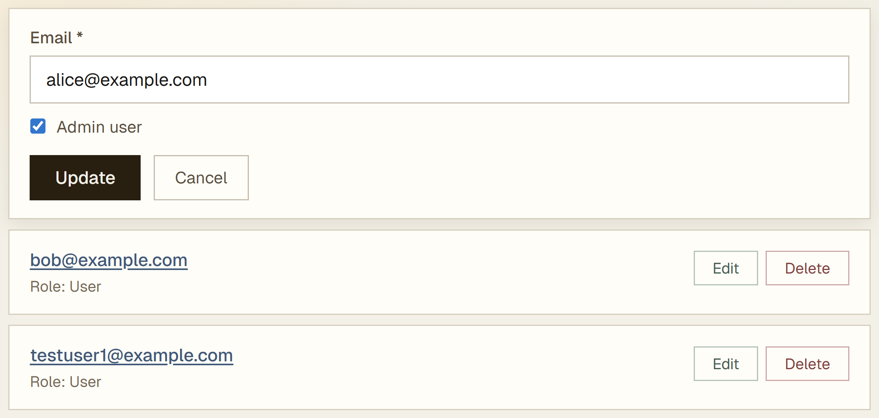

Testing the Admin Panel*
Every part of the backend logic can be tested with Postman. Here is how to test some of the Admin functionalities:

Step 1: Preparation
Prepare two new accounts – one of a general user and one admin. It’s always good to test with new accounts, not already existing ones, so that the results are as precise as possible. The existing accounts may be "contaminated" or contain too much information to be convenient.
Run a POST request to register the users as was shown above. Save the tokens of both and use them for tests.

The Regular User
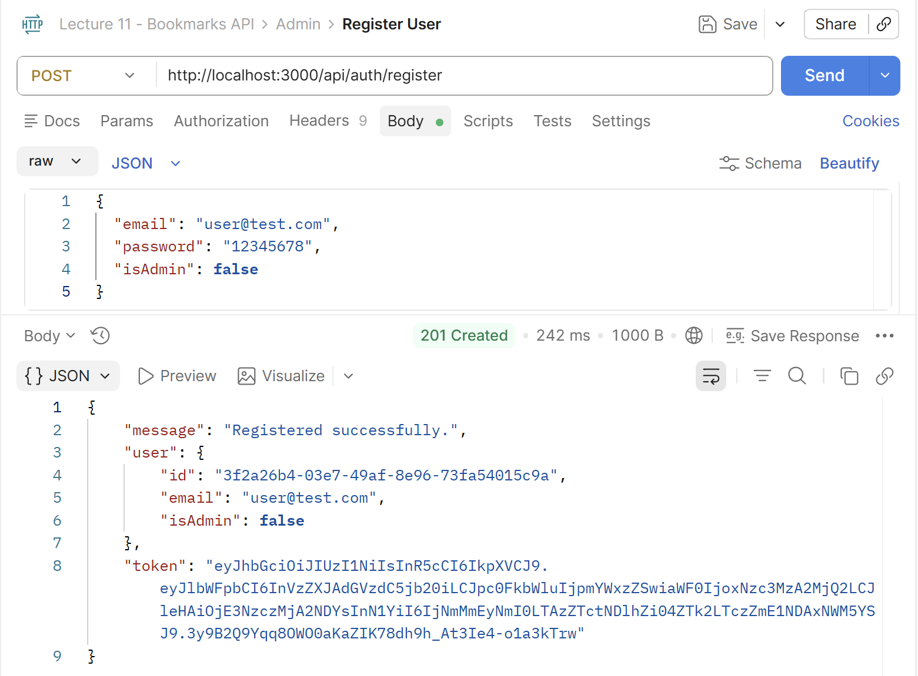

The Admin
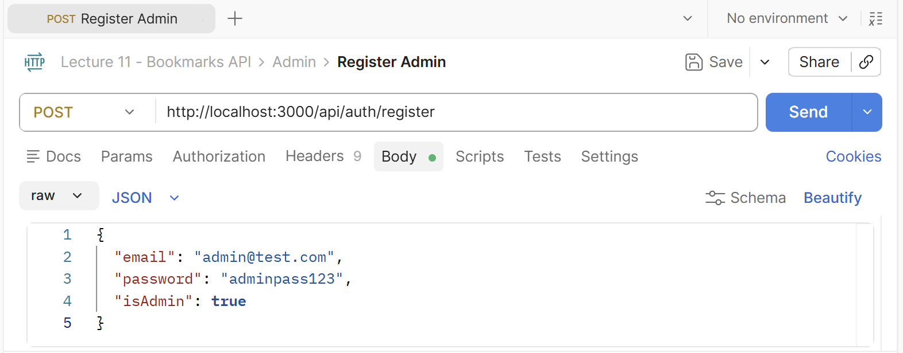
After registration however, the isAdmin parameter may stay false. In this case the admin rights must be provided manually through the Admin panel in the user interface:
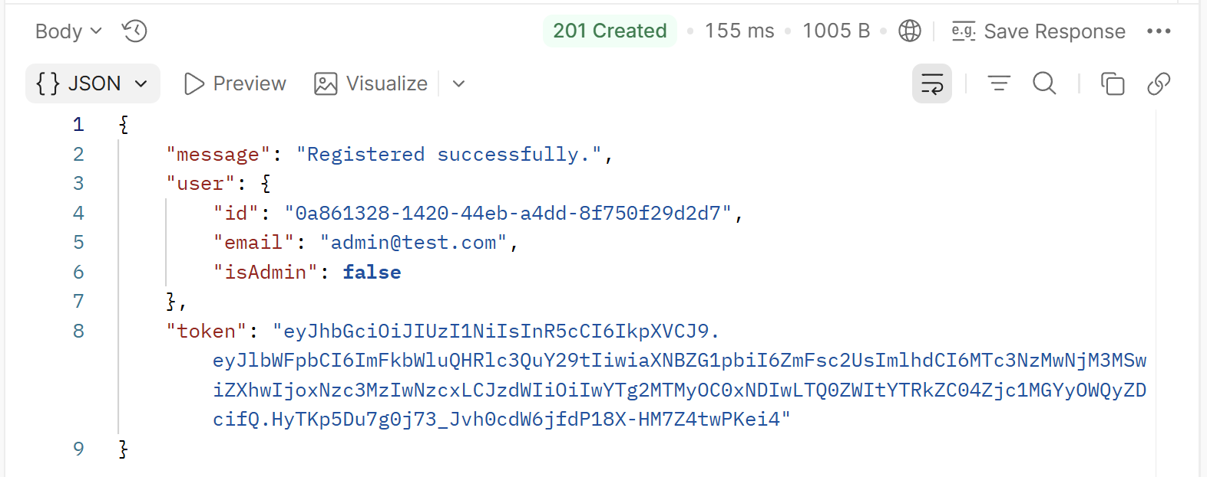

Step 2: Conduct the Tests

Test 1: Admin Access to Users
Put the common user token in the [Authorization] section first. This user should not have access to the admin panel:
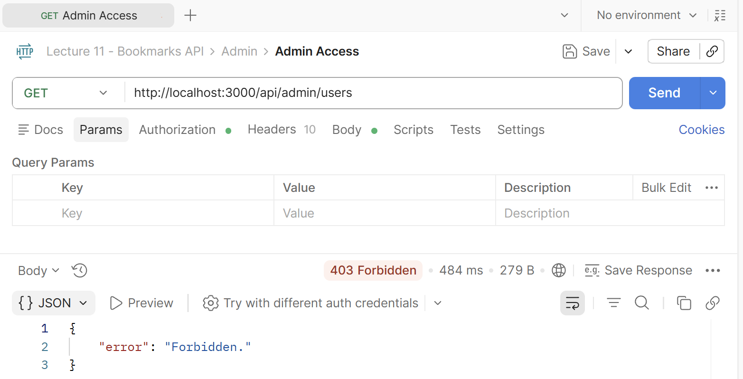
Enter the admin token in [Authorization] and see if you see all users with their IDs in the system. If the admin sees users which the common user doesn’t see, the test has passed successfully:
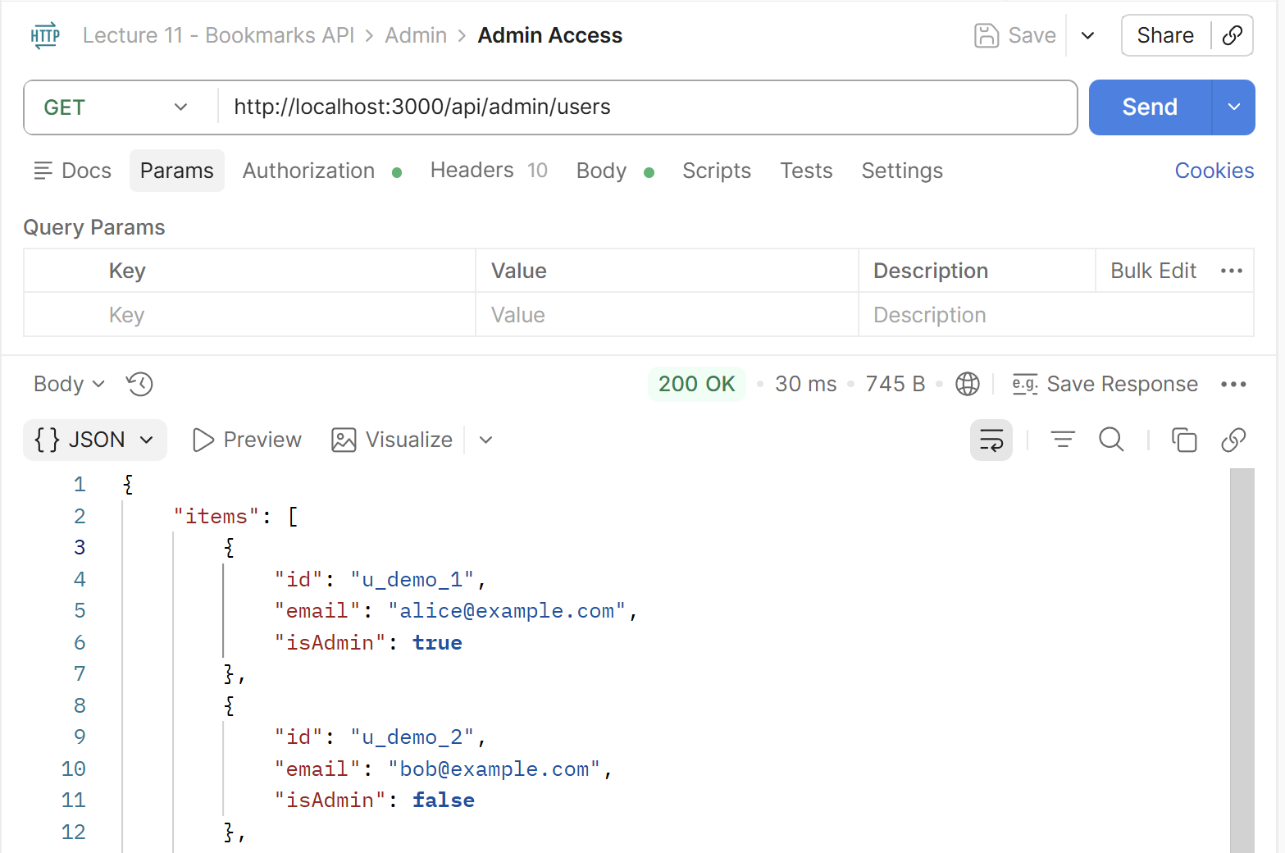

Test 2: Admin Access to Bookmarks
Use the same strategy to test the admin’s access to all bookmarks:
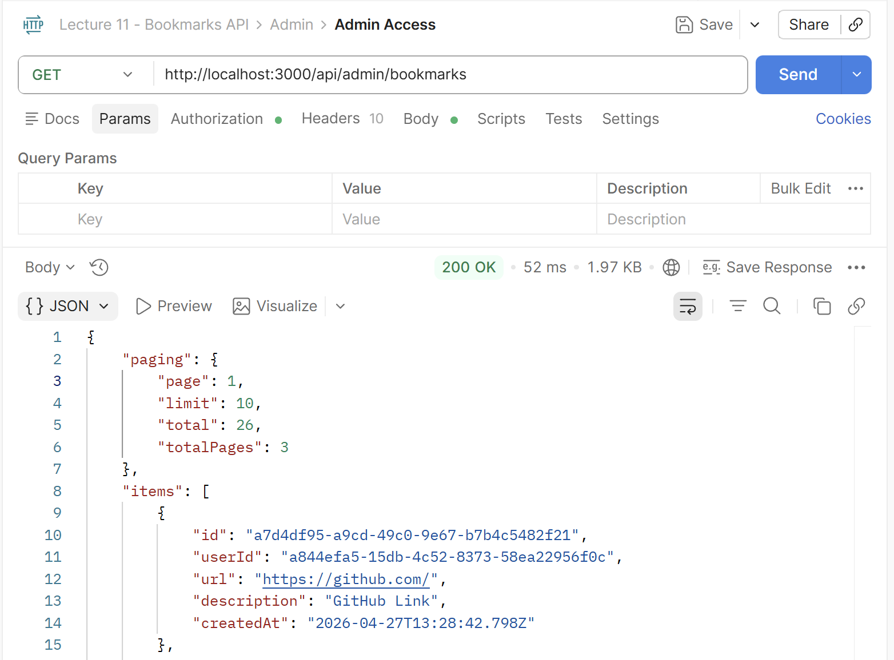

Test 3: Creating a Bookmark for Another User
Use a POST request to create a bookmark for another user through the admin profile. Copy a random user’s ID from the ones you got from the first test and fill it in in the following request body:
{
"userId": "123",
"url": "https://stackoverflow.com",
"description": "Developer Q&A platform"
}
The result from the admin profile should be [201 Created]:
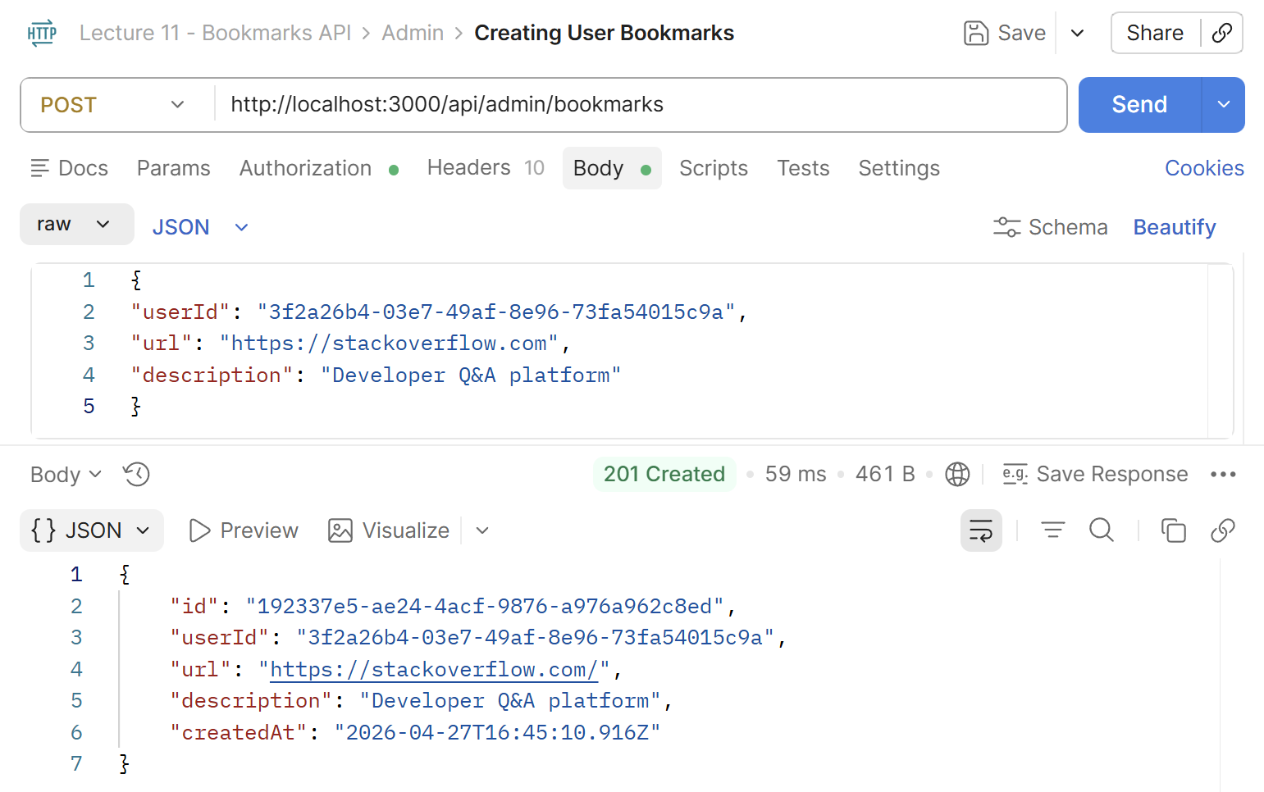
The result from the common user profile should be [403 Forbidden]:
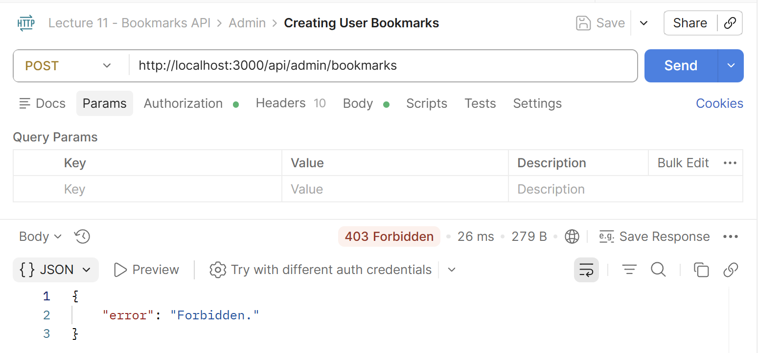

Test 4: Deleting Users
Delete the user by ID. In this case the user ID is a long code. The admin should get [200 OK]:
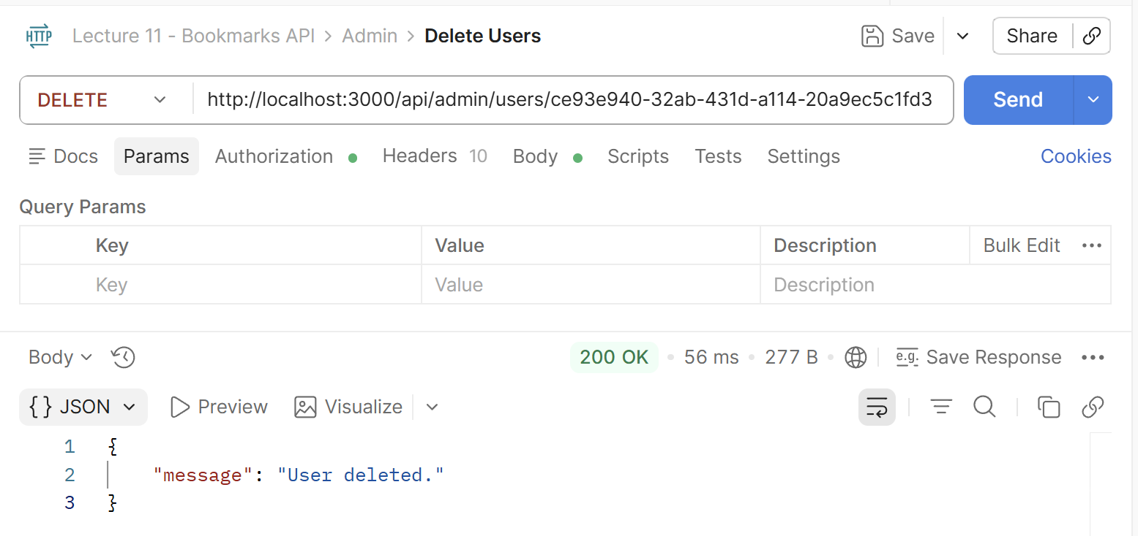
A common user should get [403 Forbidden]:
